User Manual
For
Maintenance Module
Version-1.1
Contents
1. How to Log on into IFS Application? 3
2. IFS Familiarization 4
3. Functional Object Create 10
3.1 Define Object Structure 13
4. Machine Status Change 16
5. Serial Object Creation 18
6. Machine Measurement Registration 21
7. All kinds of Basic Data Setup 22
7.1 Maintenance Basic Data 23
7.2 Basic Data for work order and PM 24
7.3 Organizational Basic Data 26
7.4 Operational Basic Data 27
7.5 Tools basic Data 27
8. Machine Fault Reporting 28
8.1 Historical Information: 41
9. Preventive Maintenance 41
9.1 Create PM action based on “Separate PM Action” 42
9.2 work order Generation Automatically 46
9.3 Condition Base Maintenance 48
9.4 Route PM Action 51
9.5 Generate work order for Route PM Action 54
10. Setup Standard Jobs 57
Appendix 59

1. How to Log on into IFS Application?
>>Open Internet Explore>>Enter appropriate IP in address bar>>Press Enter>>Click IFS Application - APXTST
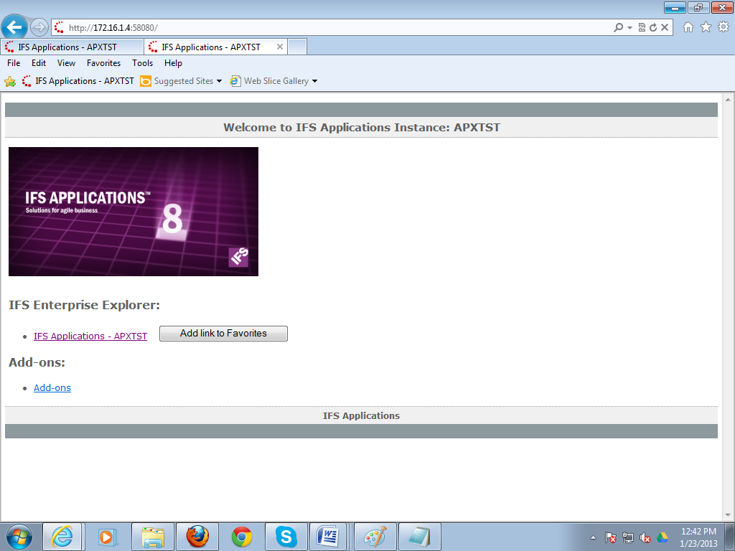
Window: Internet Explore
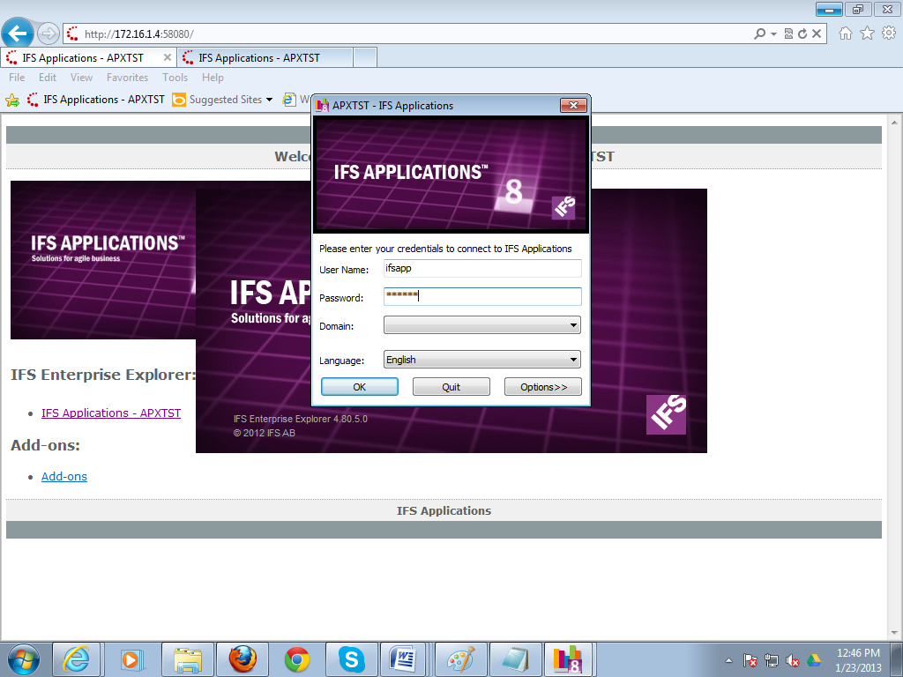
>>Enter User Name>>Enter Password>>Press OK

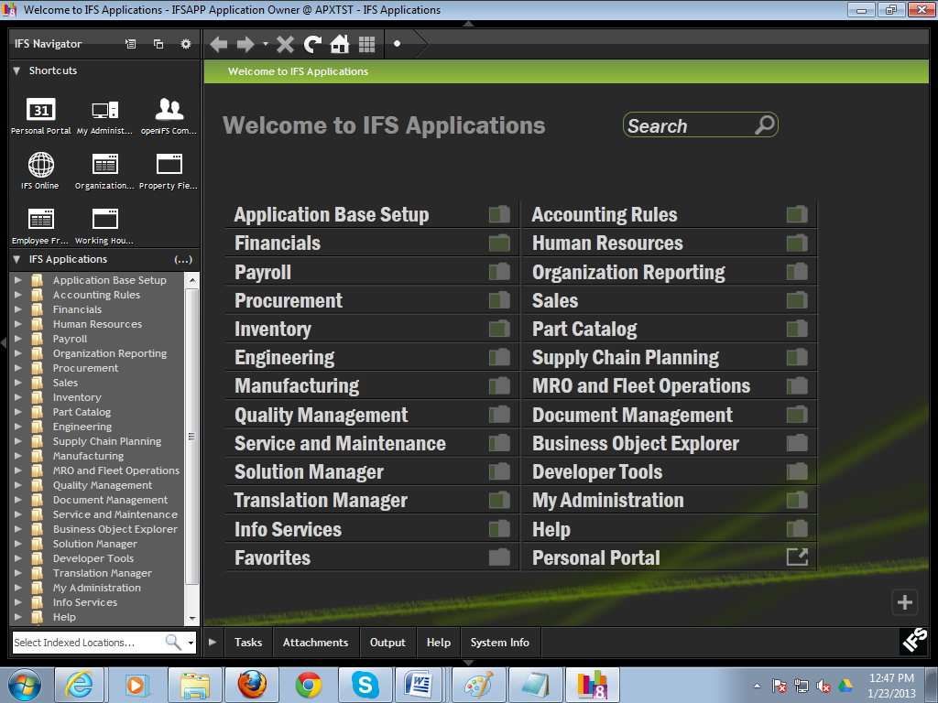

2. IFS Familiarization
Frequently Ask Question – FAQ
Question List
- How to open a new window?
- How to search a new window?
- How to save a new record?
- How to select data from LOV?
- How to Search a record?
- How to delete a record?
- What are the shortcut keys of IFS?

Question 1: How to open a new window?
Solution:
You can open a new window using navigator path. Suppose you want to open “Customer Invoice” window. Each window has a name. You can open this window using navigator,
Click on arrow sign>Sub Folder will open>>Click the name of window
Path: Sales\Invoicing\Customer Invoice

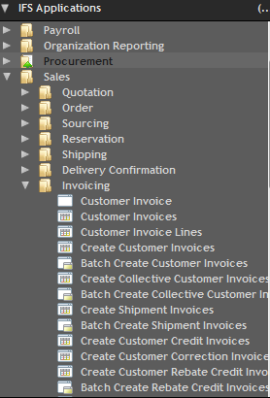
Question 2: How to search a new window?
Solution:
If you know the window name, you just write the name of window in the navigator text box.
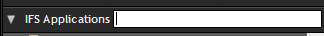
Then you will see the window in the tree menu.
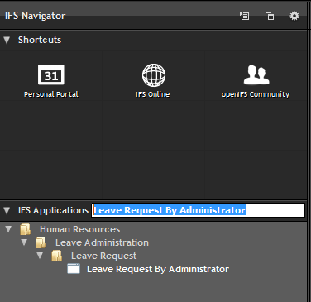
You can also type the window name like bellow
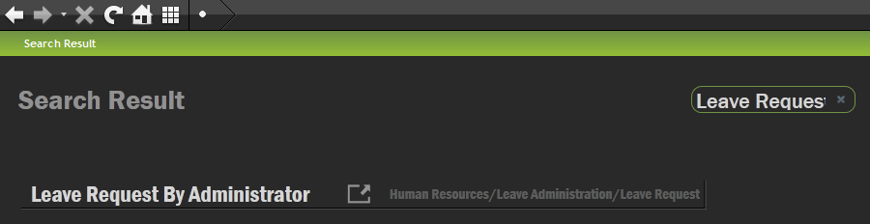
Question 3: How to save a new record?
Solution:
After Opening the window, you click  button.
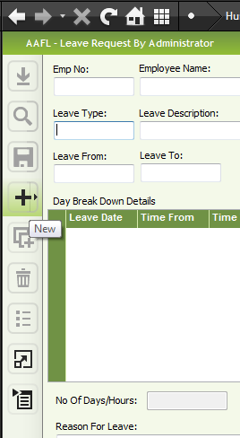
Then you will see some text fields are red color and some are normal color.
Red color field are mandatory field. Non color field are non mandatory. But you have to understand each and every field meaning when you will work on specific window.

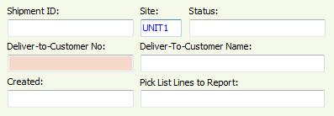
After entering all data relevant information in the window click  button.
One thing you have to memorize after editing any information you have to save the data.

Question 4: How to select data from LOV?
Solution:
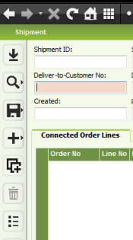
In the above picture you can see mouse cursor in Deliver-to-Customer No, now you see 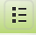 List of values is enable. So you can now select data from LOV whenever the LOV button is enable.
You will care full when entering data in any field, keep an eye whether LOV button is enable or disable. If LOV is disable it means you have to enter data by typing/manually.

Question 5: How to Search a record?
Solution:
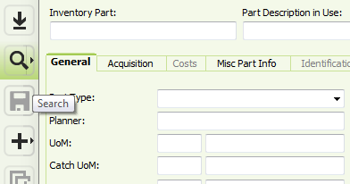
>>Open the window>>Click  button>>New sub window will open
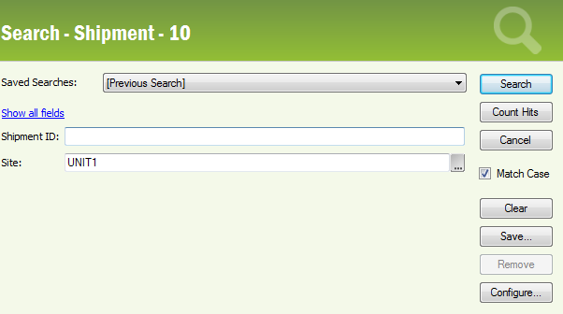
Enter search parameter. In the above picture Shipment ID field taking searching parameter. Click Button.
After clicking search button the master window is open with searching data items
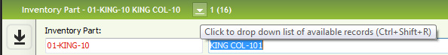

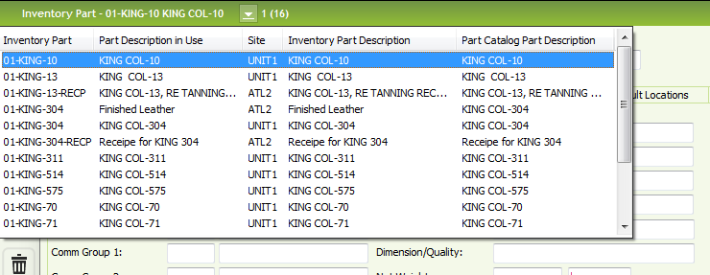
Question 6: How to delete a record?
Solution:
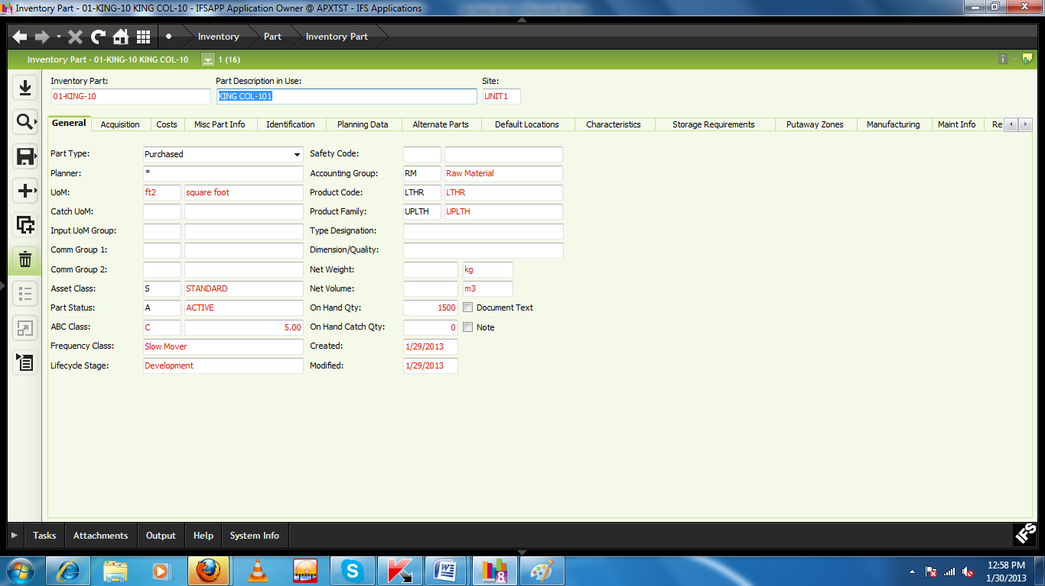
>>Search the specific data which you want to delete>>Click  button>>
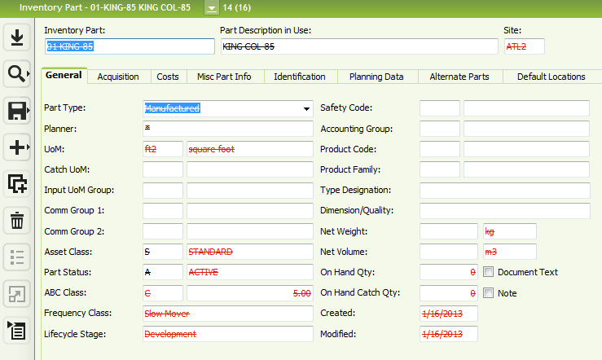
>>After clicking delete button screen shows like this.>>Then click button>>
Here you have to do like bellow
- Search the data which going to delete
- Click Delete Button
- Click Save Button

Question 8: What are the shortcut keys of IFS?
Solution:
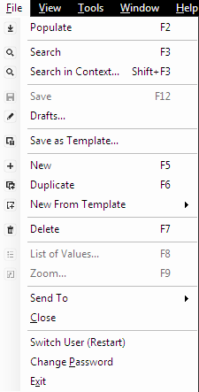

Functional Object Create

Path: Service and Maintenance\Equipment\Functional Object\Functional Object
Before creating functional object need to create Object level. Put Cursor to the object level field and press (F9). 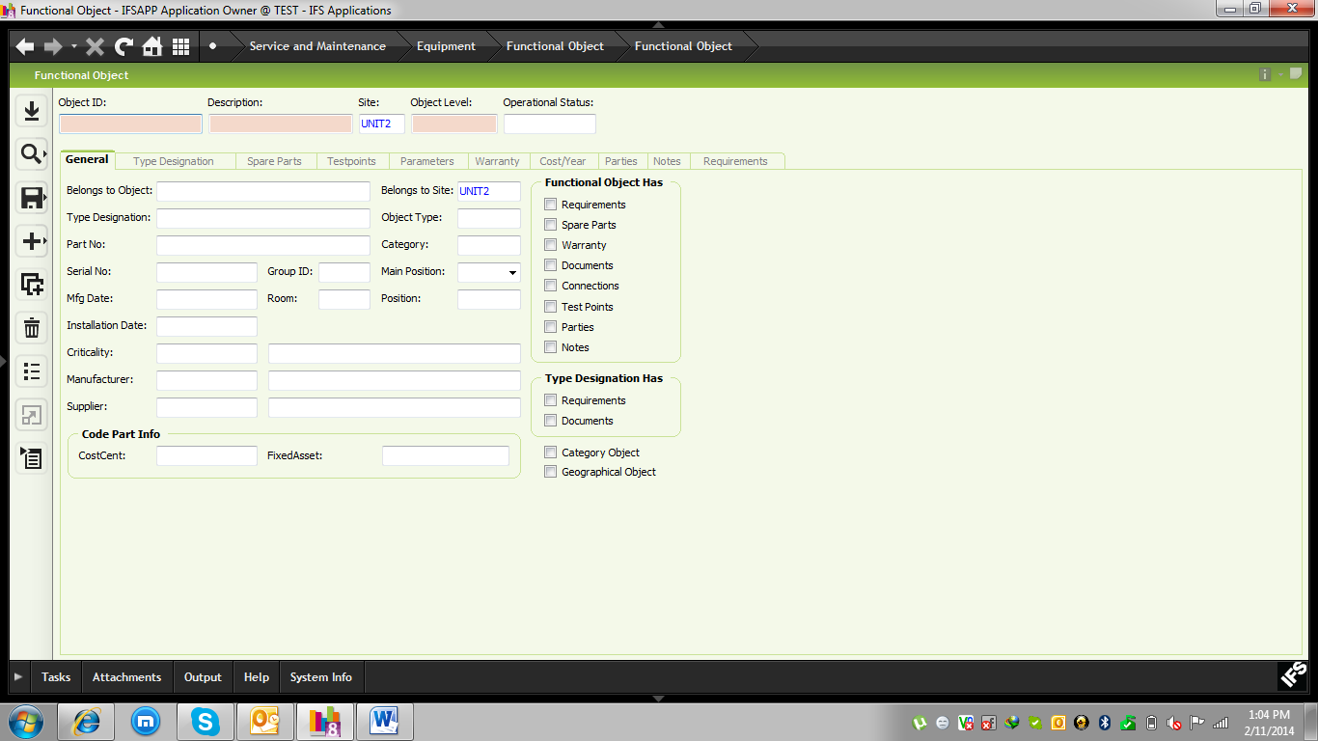
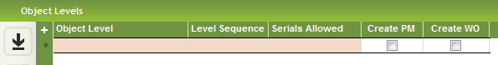
After saving data in required filed below window will come. For which object level work order will be generate or not based on that click “Create WO”
PM: Create Preventive maintenance
WO: Create Work Order
If APEX wants to create preventive or Work order whole department then they click the PM and WO or specific machine wise they can define the PM and WO.

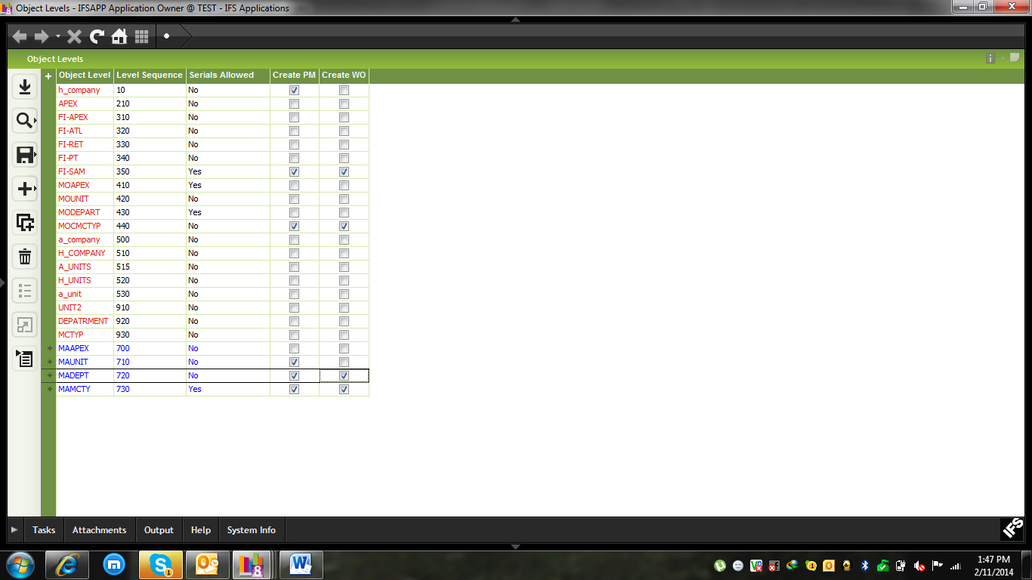
After saving data below window will come.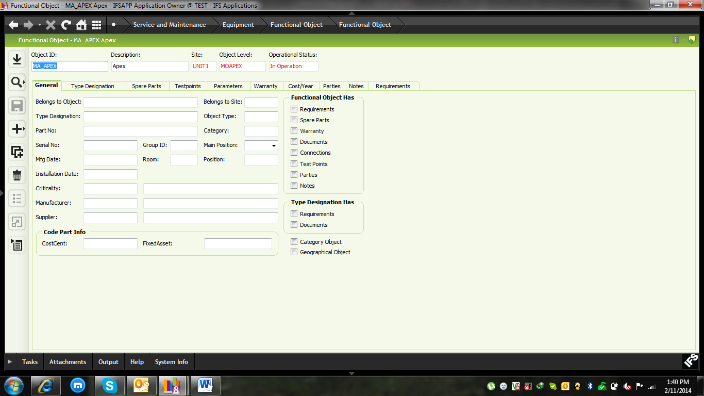

3.1 Define Object Structure
Put Cursor into “Belongs to Object” field then select specific Object.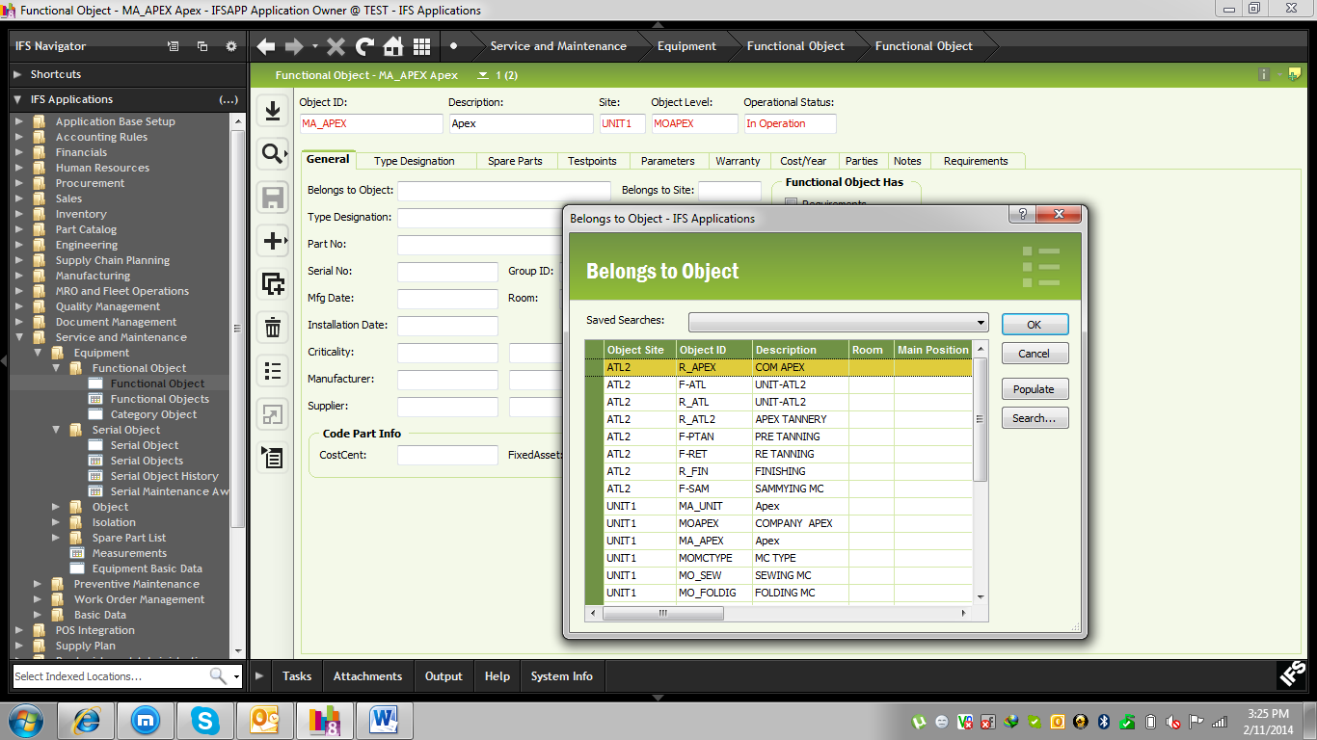

After Adding all components to the structure then user can see the tree view.
Path: Business Object Explorer
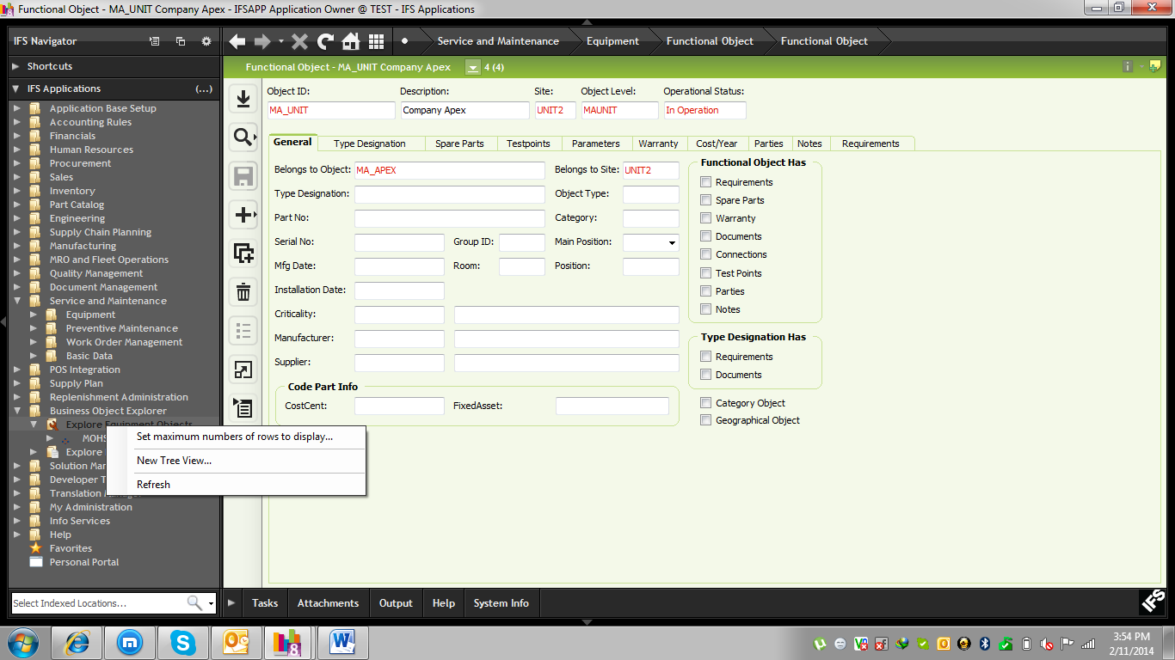
Click on the “Change”

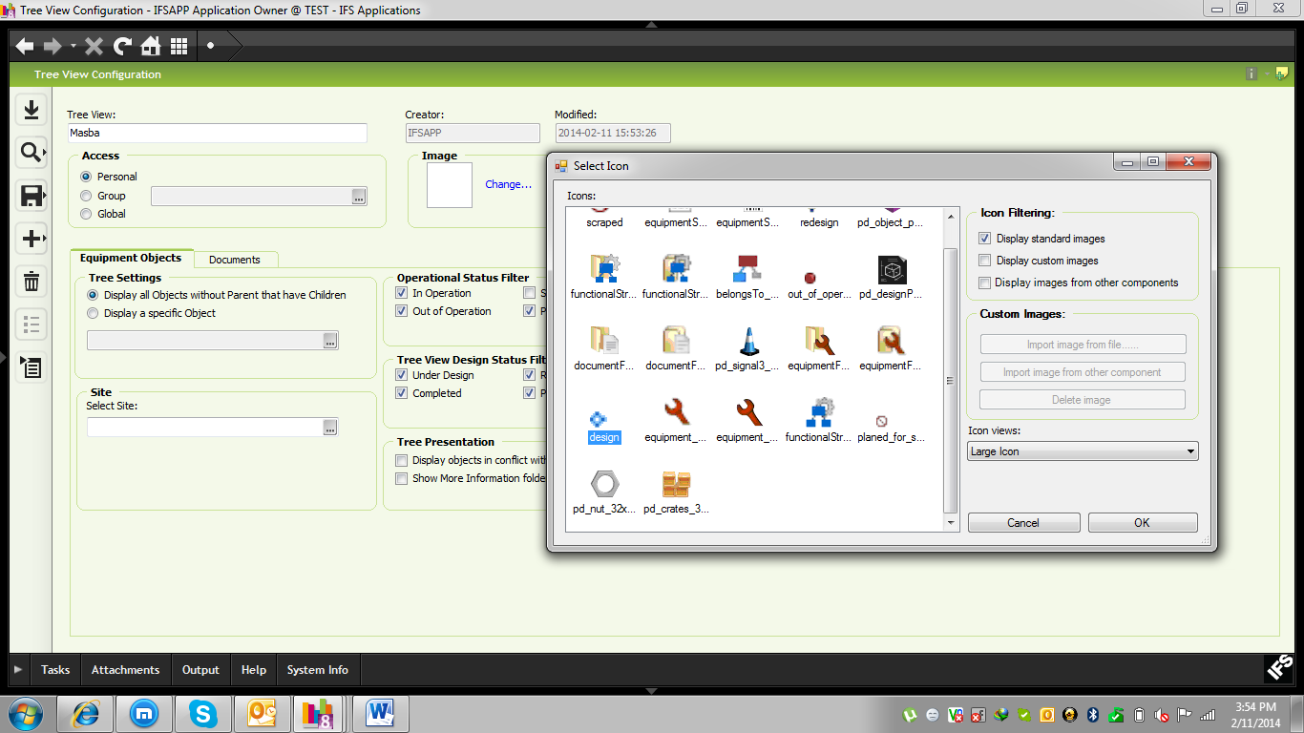
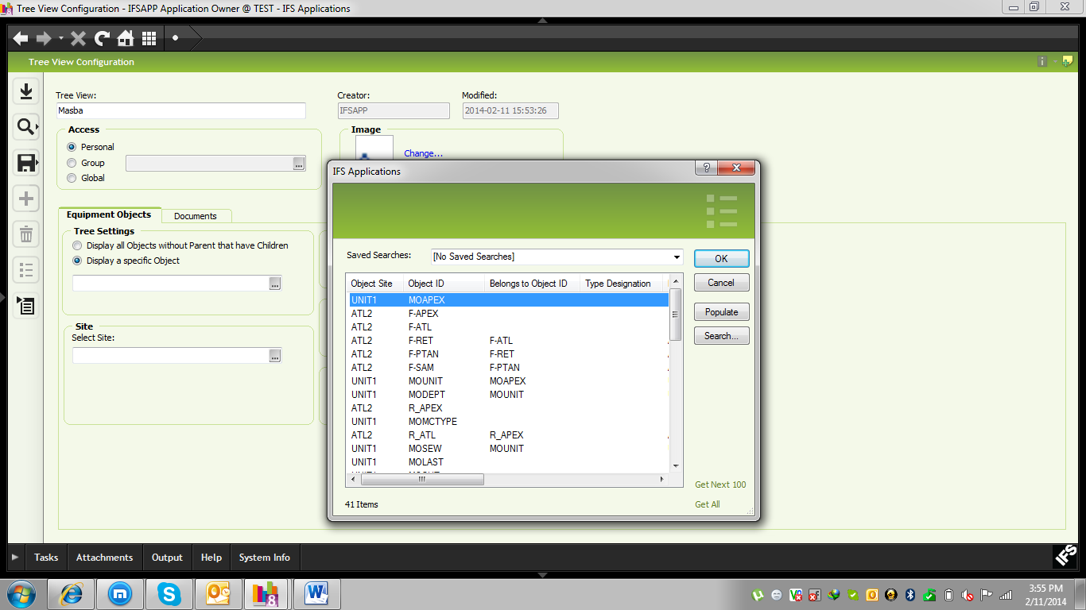

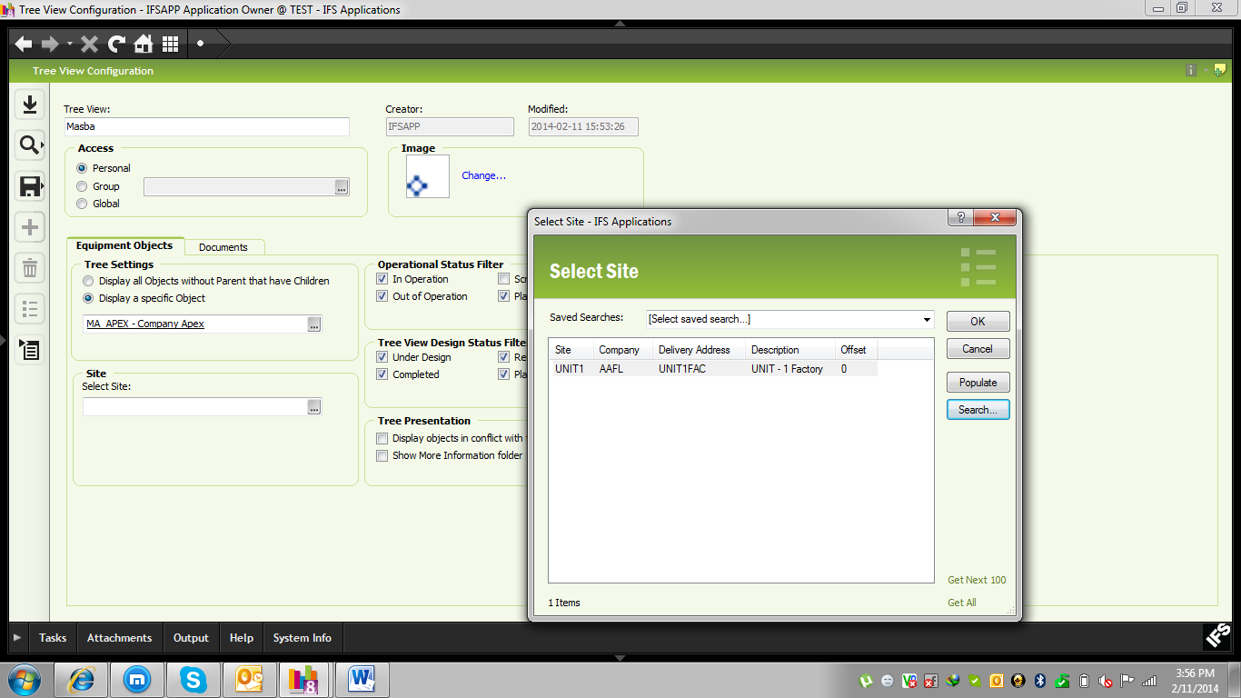

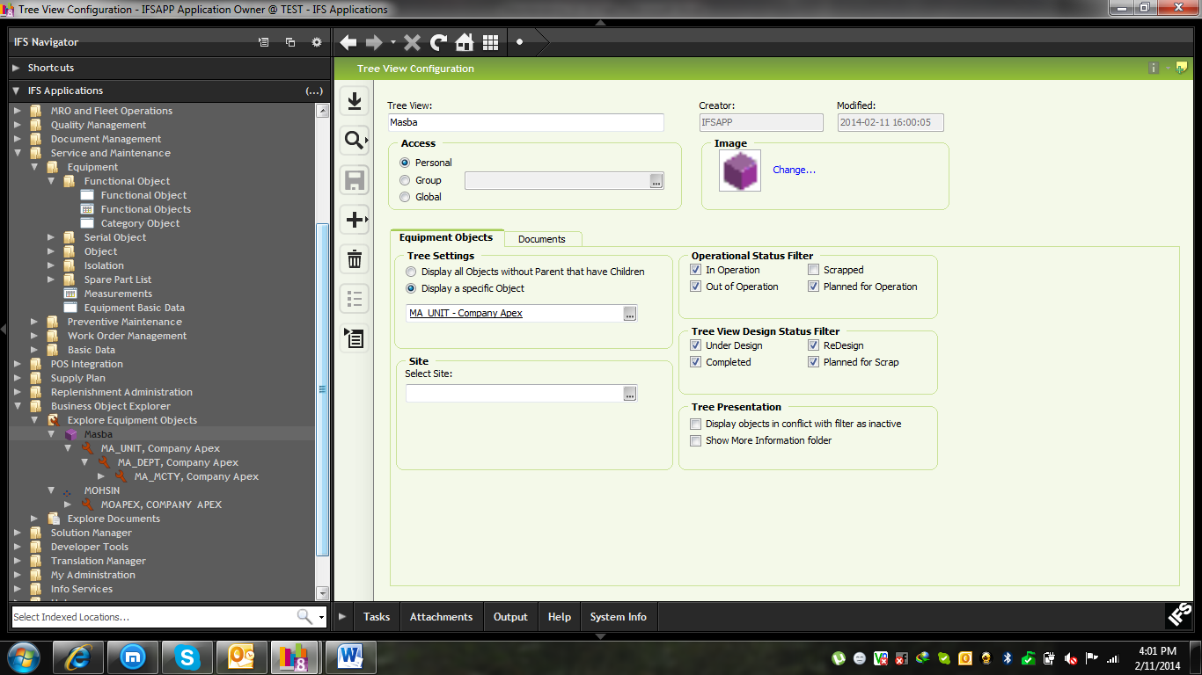

Machine Status Change
Path: Service and Maintenance\Equipment\Functional Object\Functional Object
If any Machine is out of operation then select specific functional object and RMB on the header 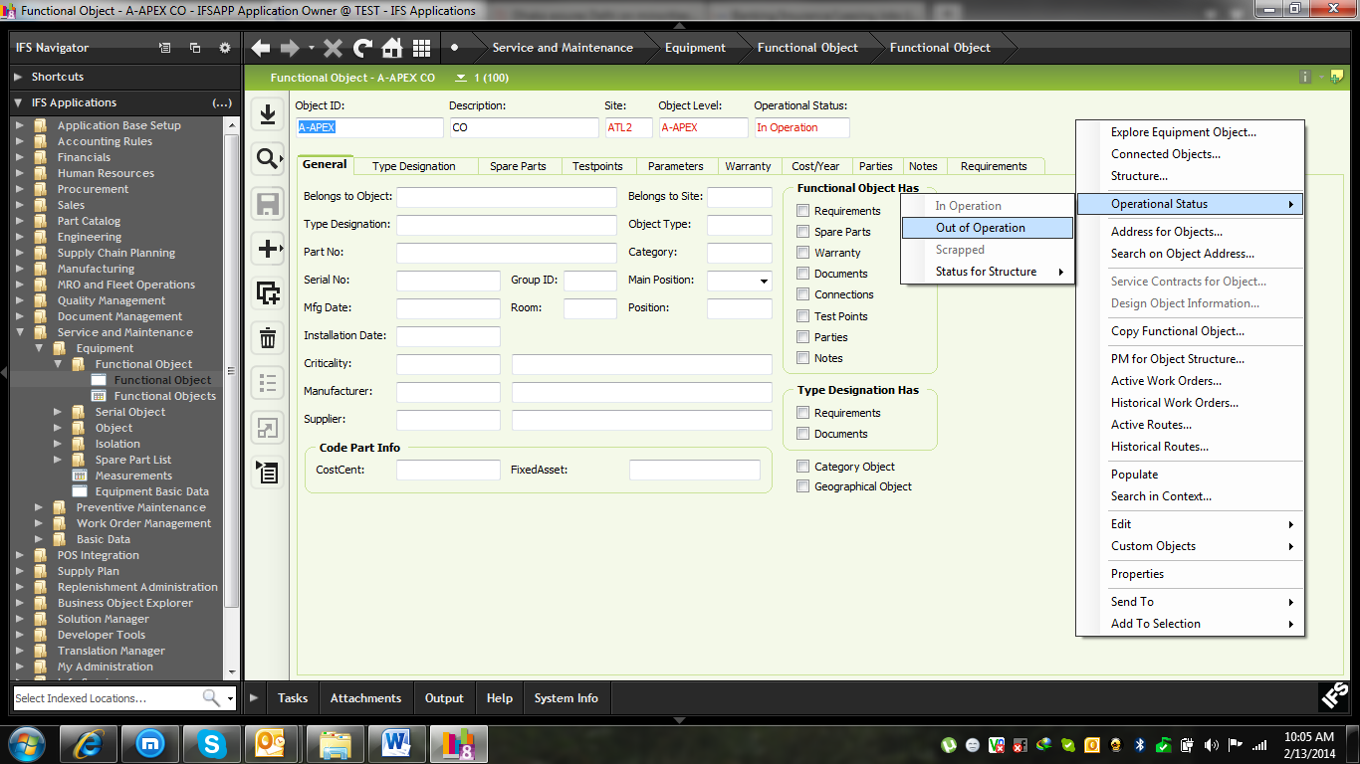
After doing all operations/corrective operation when machine is OK then RMB on the header and click “In Operation”.
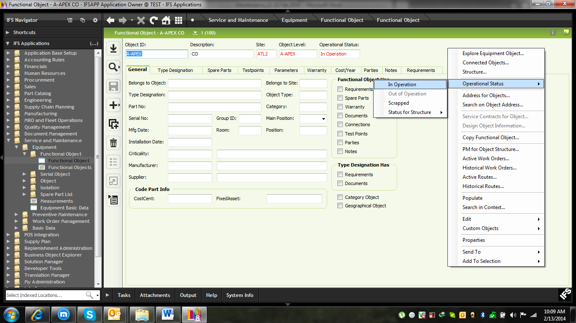
If machine is fully unusable then make it Scrapped
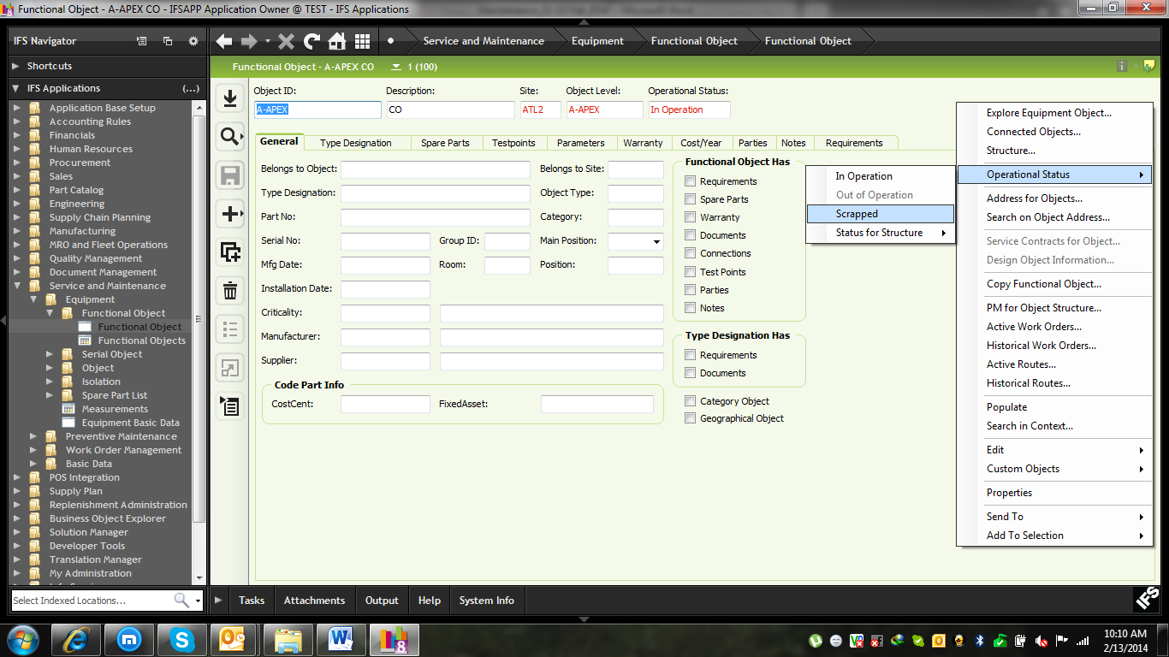

Serial Object Creation
Path: Service and Maintenance\Equipment\Serial Object\Serial Object
For All Serial objects inventory Part will be Serial Tracking. For that go the inventory part and Search specific part no and click “At Receipt and Issue”, “In Inventory” and “After Delivery Serial Tracking”
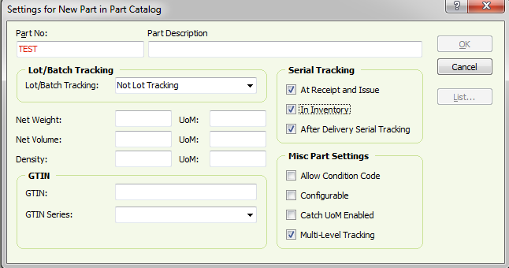
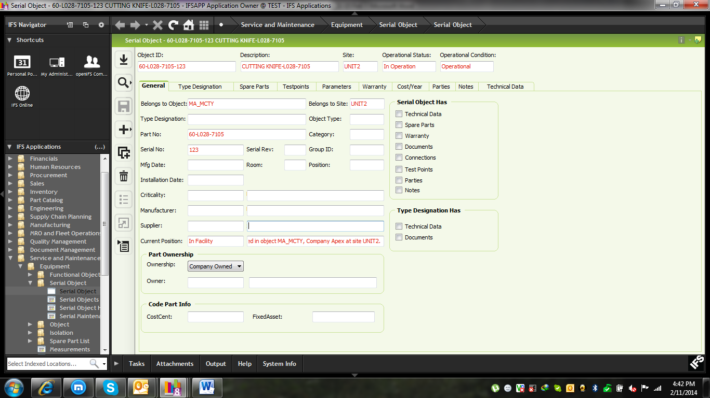
In Spare Parts TAB user can input the Spare parts information.
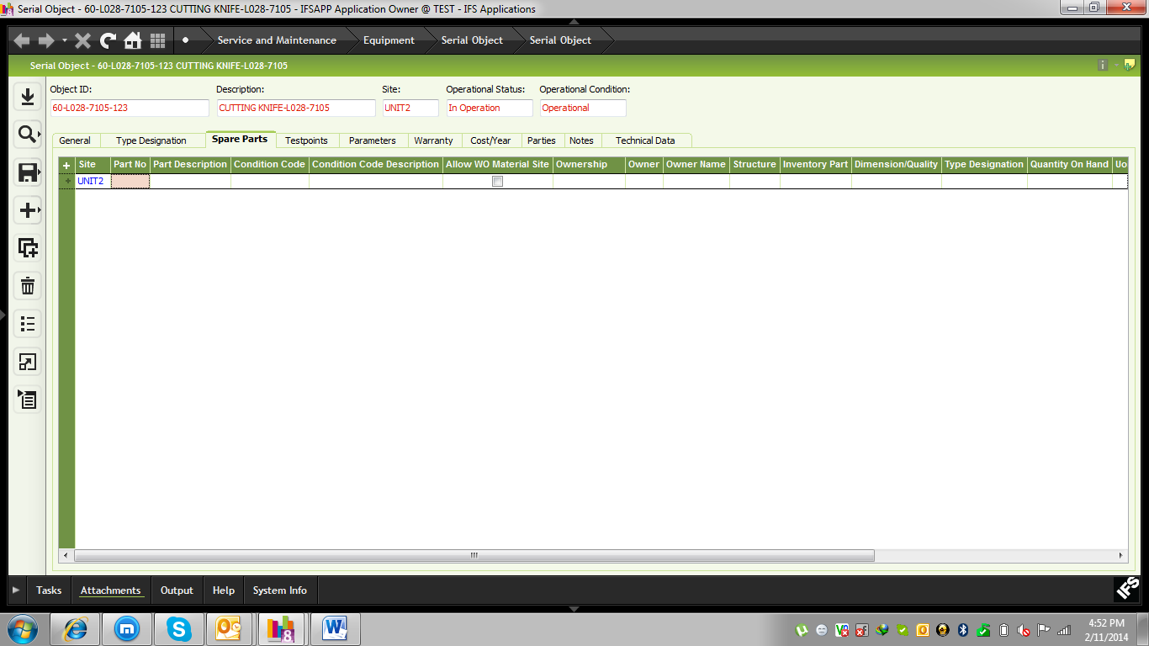
In Test Point TAB: User can input their testing Information.
Note: Here Location field shows in which area of the machine will be tested.
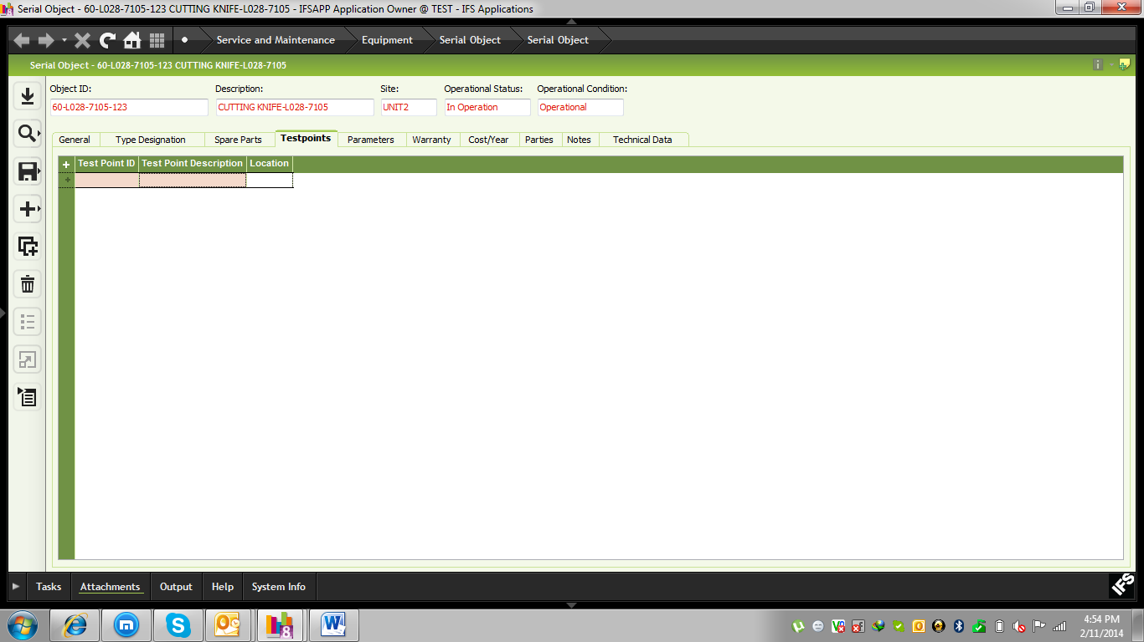

In Parameter TAB user will input all the Parameters. Based on which parameter machine will be test.
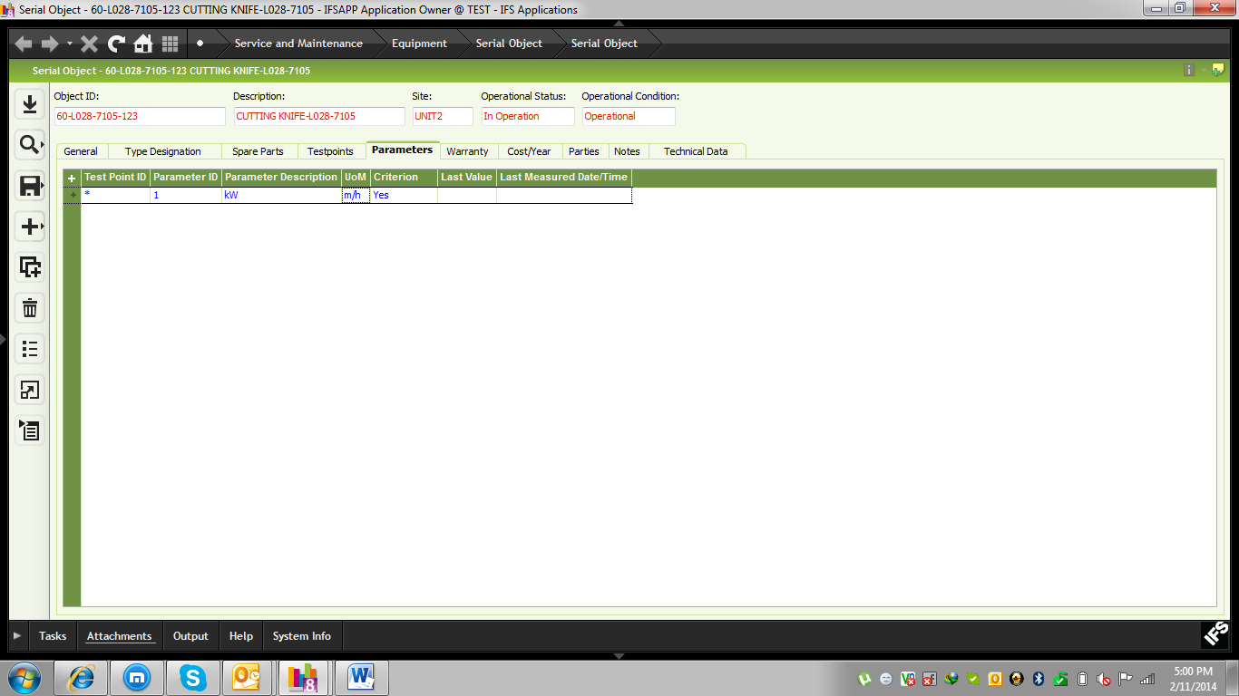

Machine Measurement Registration
Path: Service and Maintenance\Equipment\Measurements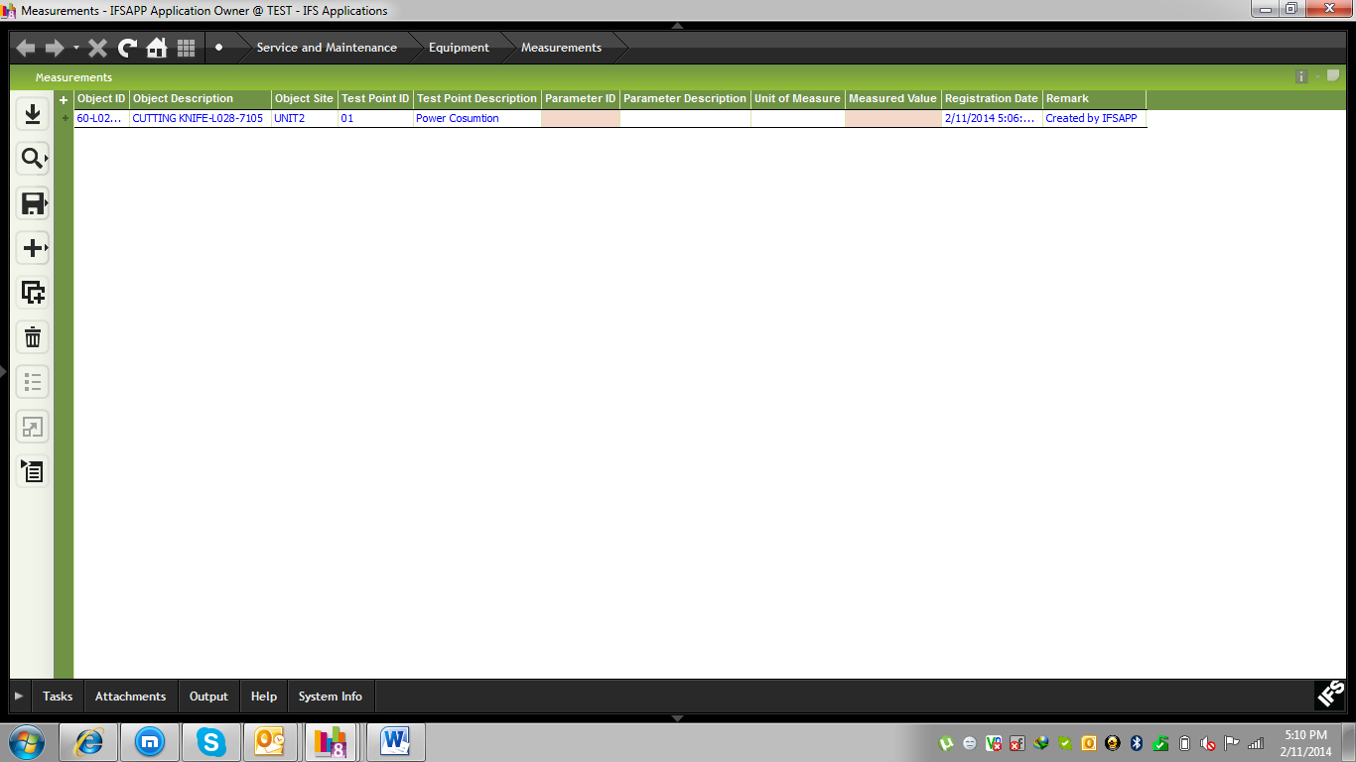

All kinds of Basic Data Setup
Path: Equipment Basic fata: Service and Maintenance\Equipment\Equipment Basic Data
In Object Level we will input First Category.

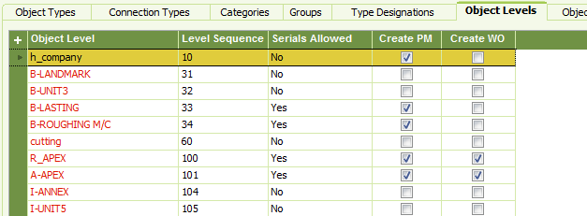

In Object Types TAB we will define our all Departments.
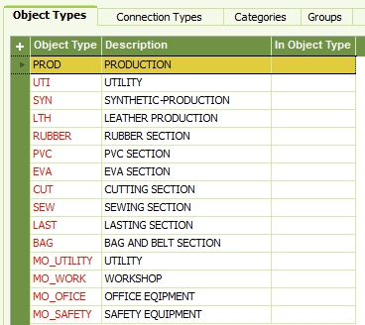
In Groups TAB we will define our Second Category.
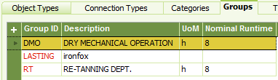

In Type Designation we will connect main Category and Second Category.
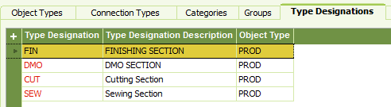

In Object Criticality TAB we will define our priority for work order.
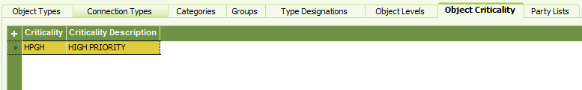

7.1 Maintenance Basic Data
Path: Service and Maintenance\Basic Data\Maintenance Basic Data
In Parameter TAB we will define our all parameters for functional objects and serial objects
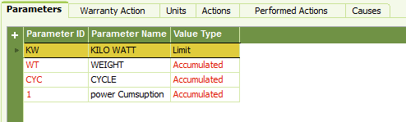
In Actions TAB we will define our all actions which will be available in work order for all functional objects and serial objects.
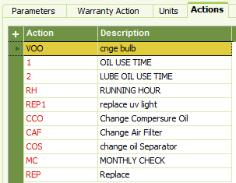

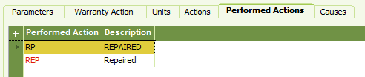

7.2 Basic Data for work order and PM
Path: Service and Maintenance\Basic Data\Work Order and PM Basic Data
All kinds of faults of functional objects and serial objects will be defined here.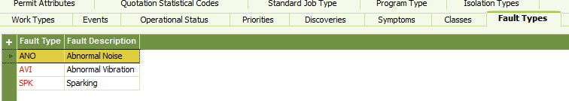
In Standard job Type TAB we will define our all standard jobs type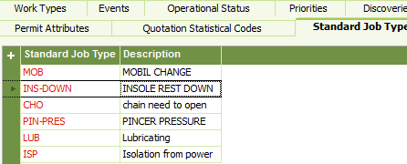

To Set Work Order Priority we will define our priorities in “Priorities” TAB
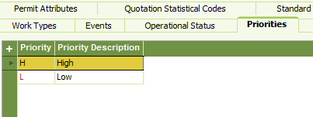

All kind of work Types we will define in “Work Types” TAB
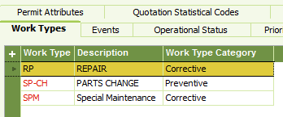
For Event maintenance we will define our events in “Event” TAB
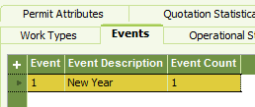
All kind of Symptoms of functional objects and serial objects we will define in “Symptoms” TAB
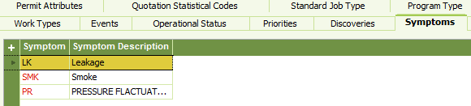

7.3 Organizational Basic Data
Path: Service and Maintenance\Basic Data\Organization Basic Data
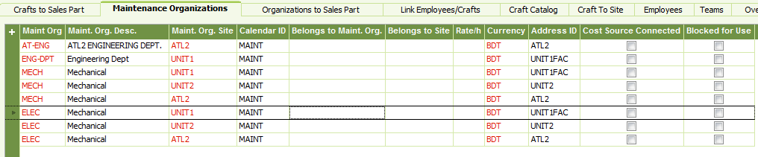

Define Employee against Department in “Employee” TAB
Input Signature, Employee name and Employee Id and Maint Org field specific department
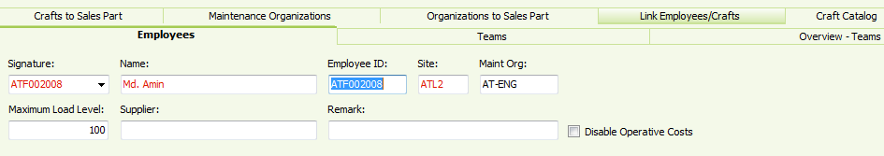
To Define Skill Level of worker we will input into “Craft Catalog” TAB
Note: In “Rate” Column we define employee work hour rate
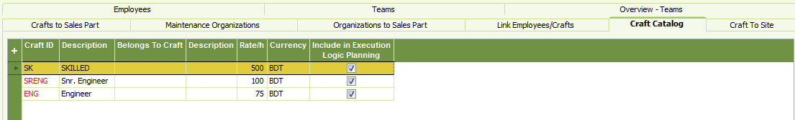

To define skill people into specific Site need to add into “Craft to Site” TAB
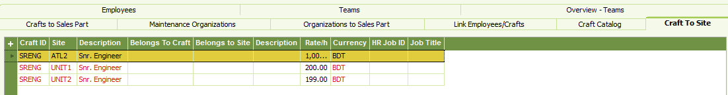
Link Employee to Craft we will input into “Link Employee/Craft” TAB
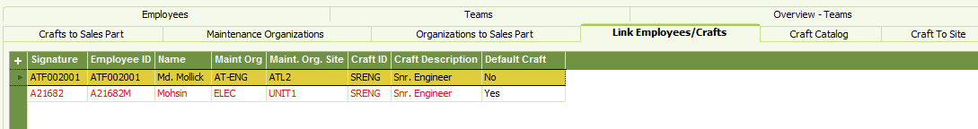

7.4 Operational Basic Data
Path: Service and Maintenance\Basic Data\Operation Basic Data
We will input all kinds of Cancel Cause in “Cancel Cause” TAB

7.5 Tools basic Data
Path: Service and Maintenance\Basic Data\Tools and Facilities Basic Data
In “Tools and Facilities” TAB we will define all kinds of Tools type.
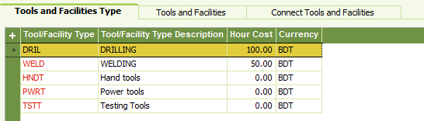
In “Tools and facilities” TAB we will define the tools Information.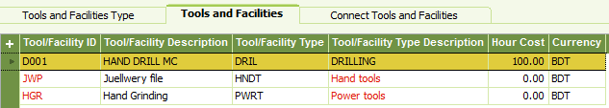
Tools define against Department will be defined in “Connect Tools and Facilities” TAB

Machine Fault Reporting

Process Flow: Entry Fault>work order>Planned>Execute work order>Report In>Finish>Historical work Order.
Path: Service and Maintenance\Work Order Management\Fault Report/Service Request\Fault Report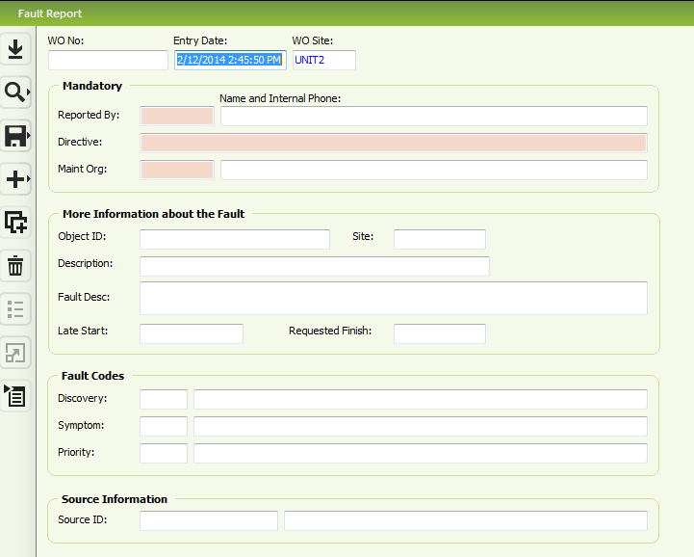
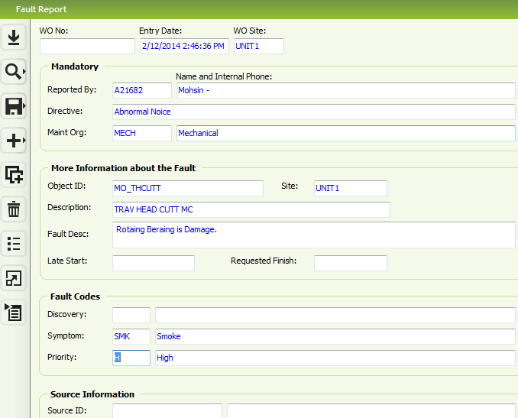
After saving data, RMB on the header and Click “Prepare”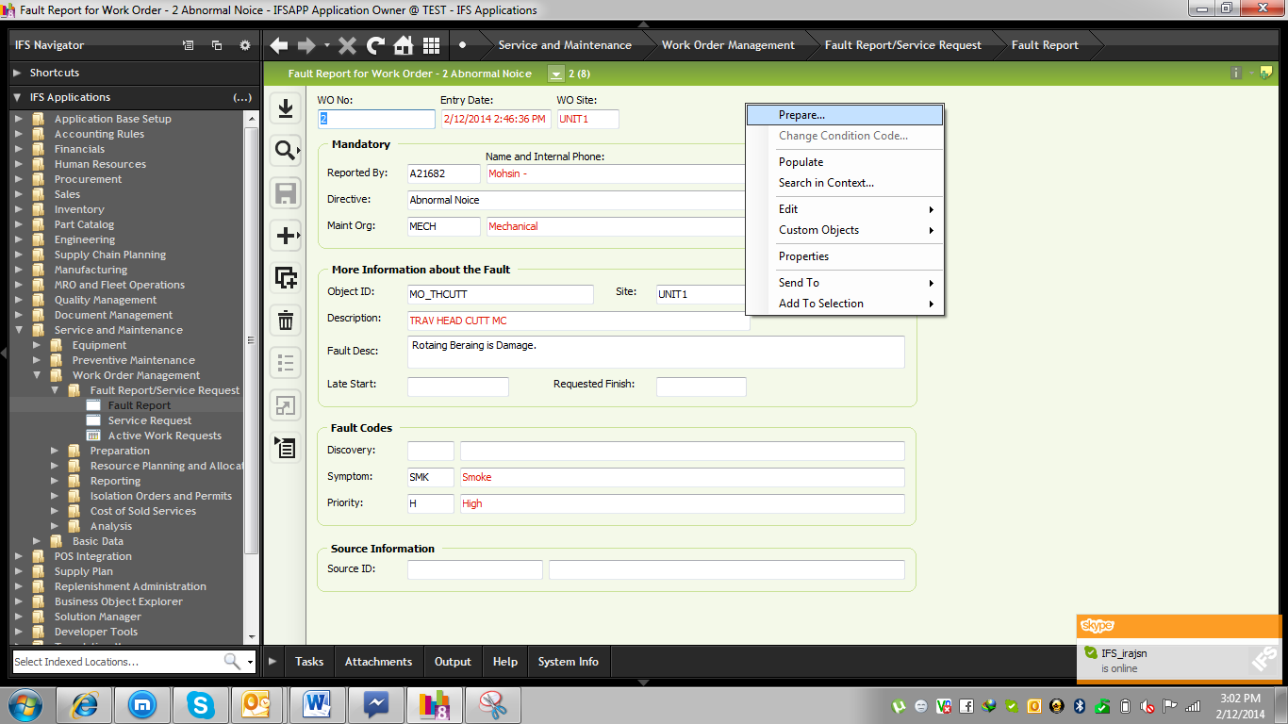
Just go the “Preparation” TAB input only Planed Start date and End Date and Work and also input work leader (who is responsible for work) and Prepare By (who assign the job) and save data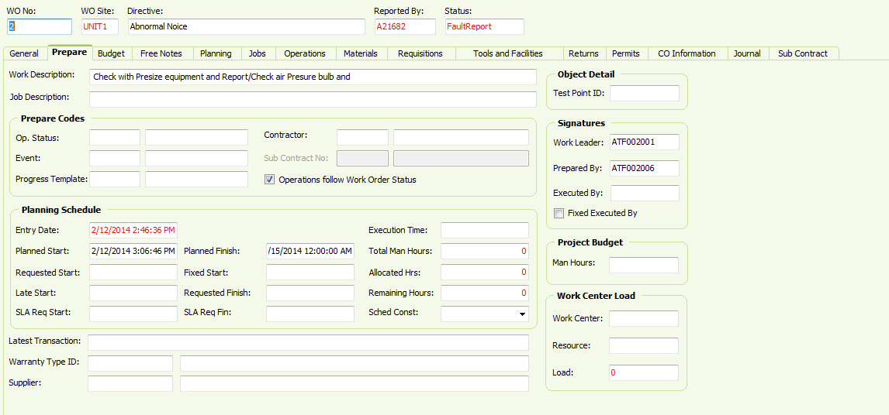

Then go the “Operation” TAB (In operation tab all operations will be defined there how Floor Eng. Will solve the issue.)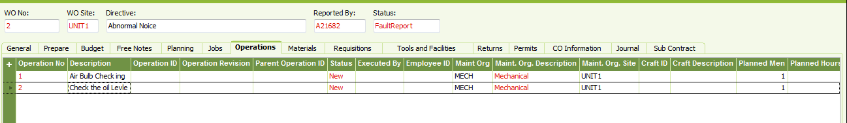

In “Materials” TAB we will define the all materials which are required for that fault machine. Note: Signature field value will be who is requesting for tools and which department (Int. Destination Id) and Due date.
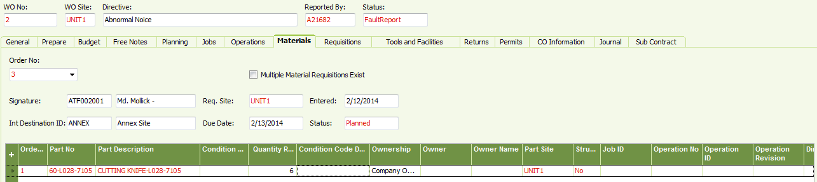

RMB on the line and click “Reserve manually” for Reserve Item.
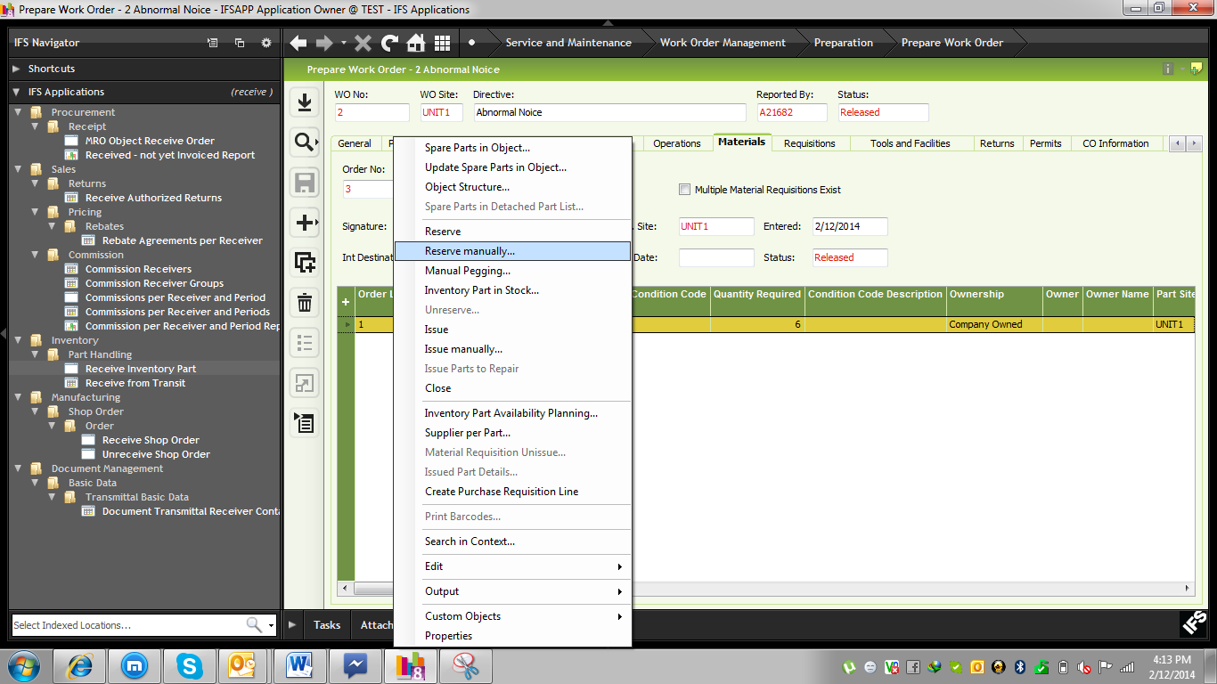
For issue item RMB on the line and click “Issue manually”
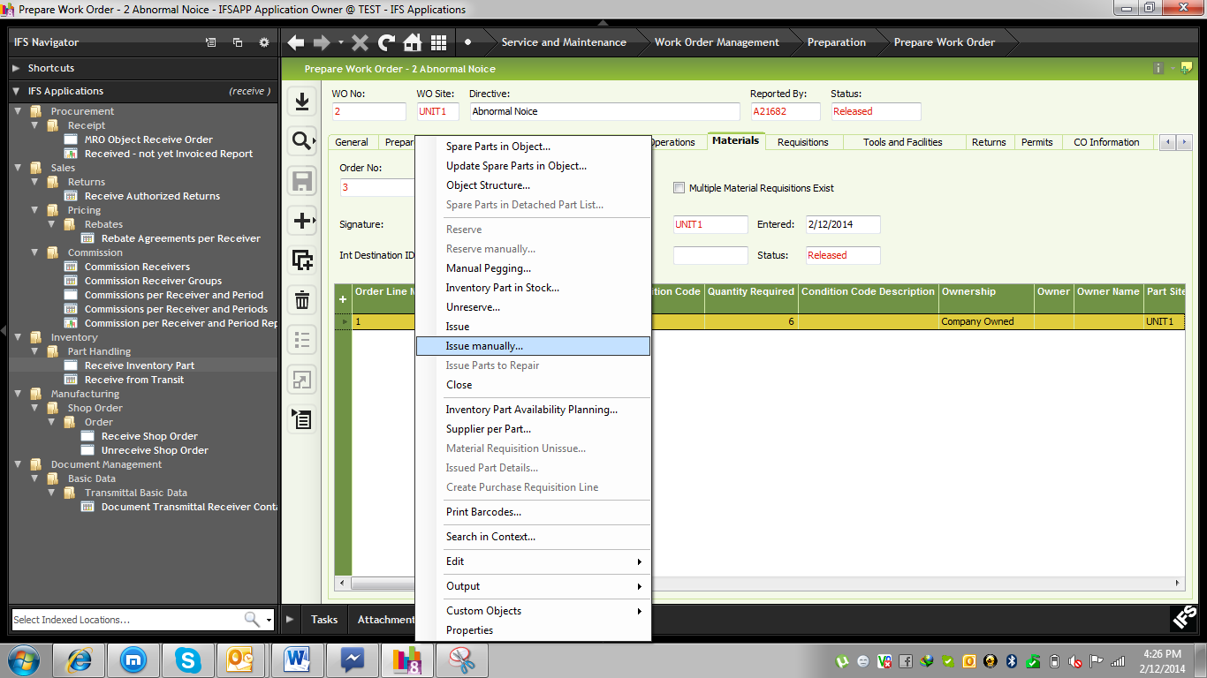
To Print Work Order RMB on the header Print>work order
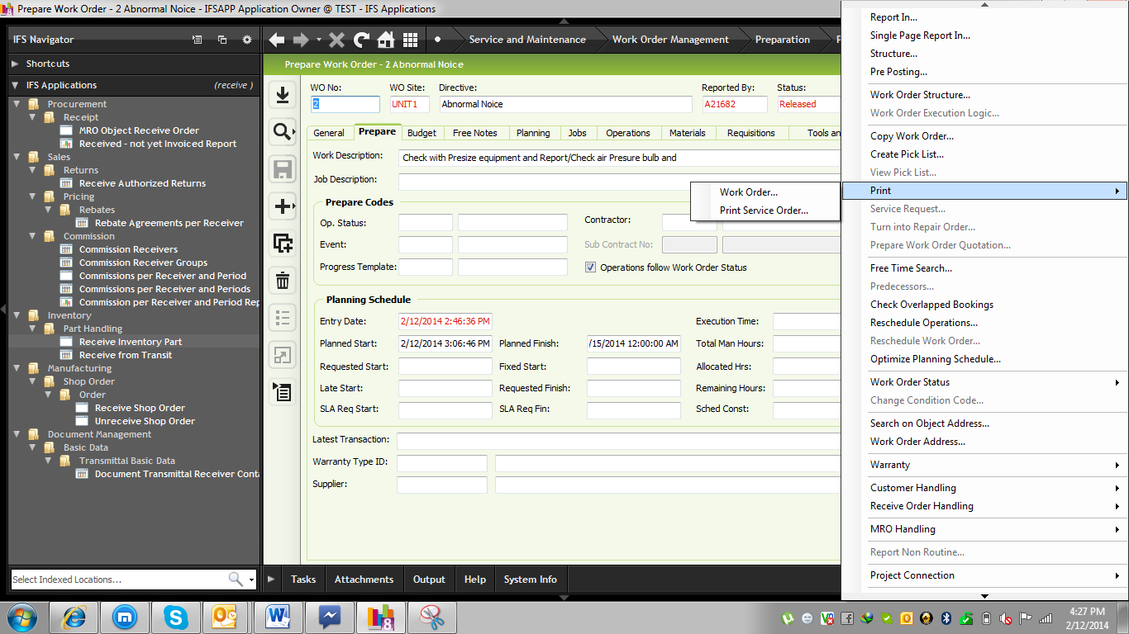
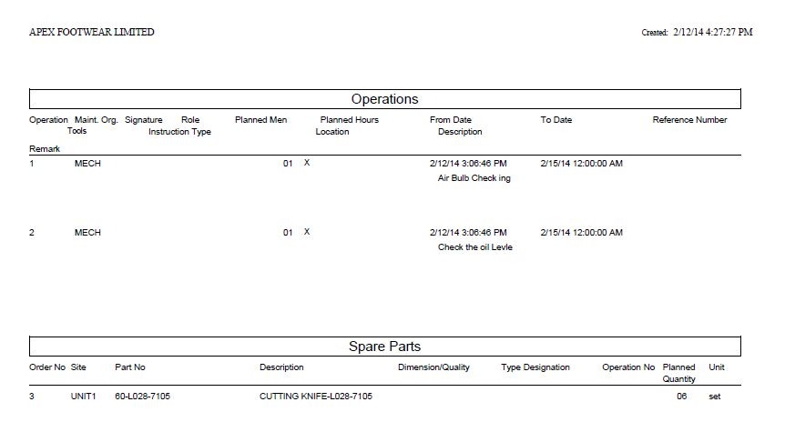
To start the work Order for that specific functional object RMB on the header and click Work order Status>Started
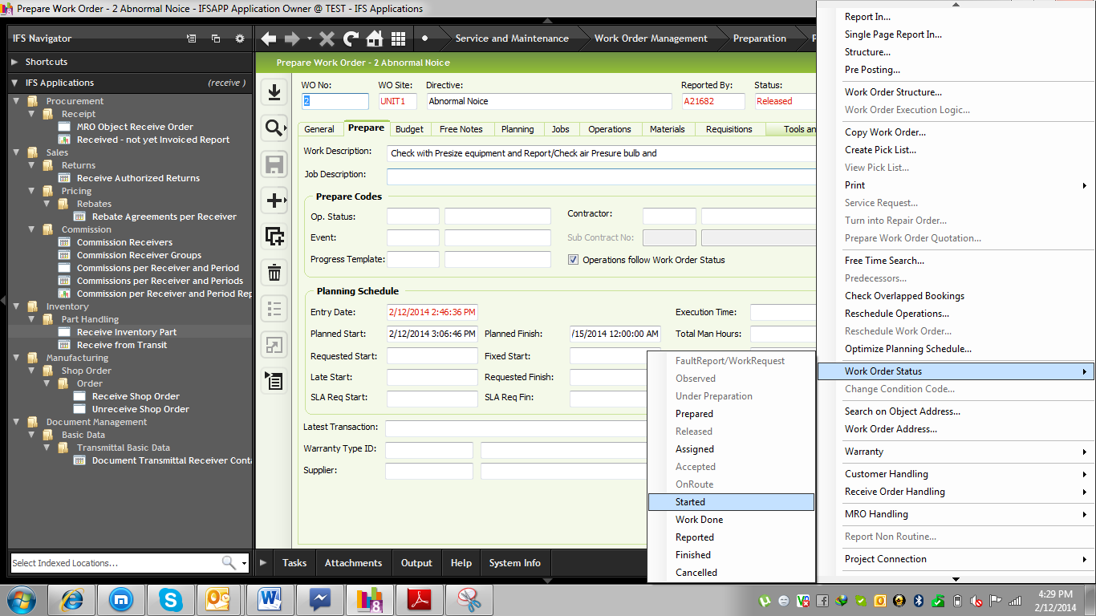
After Complete work for that faulty machine then RMB on the header Work Order Status>Work Done”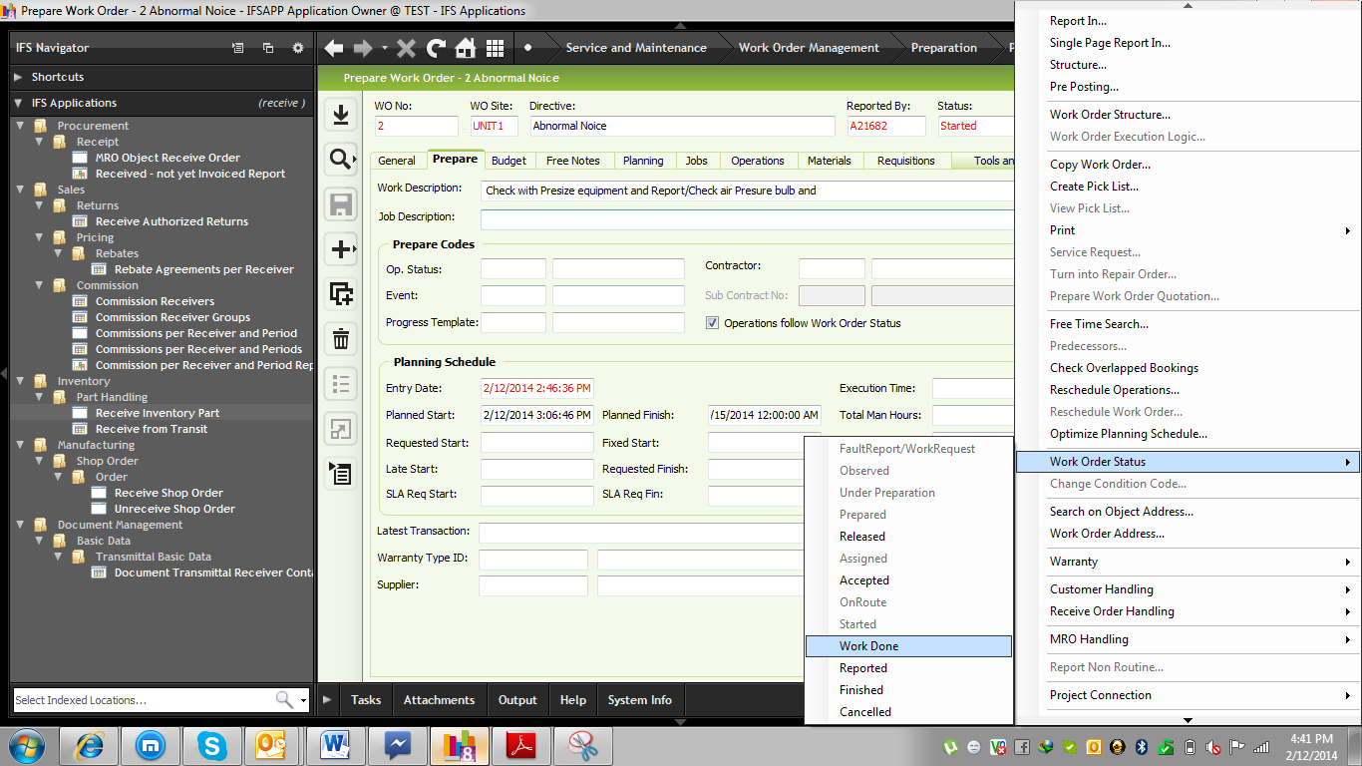
Afte work done then need to input Report Time
For Reporting RMB on the header and click “Report In”
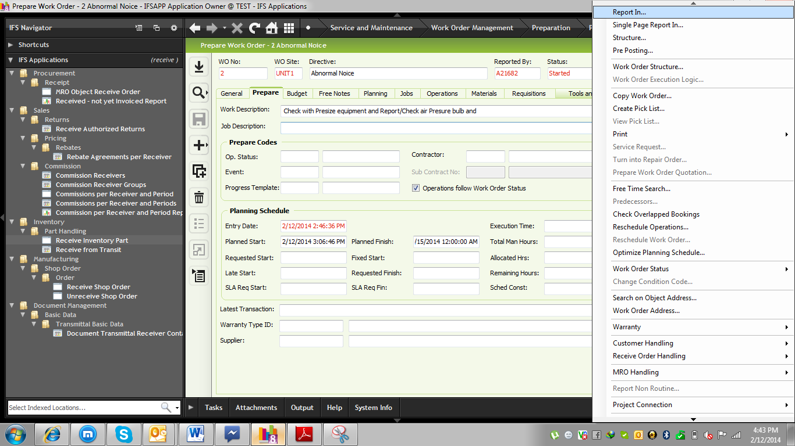
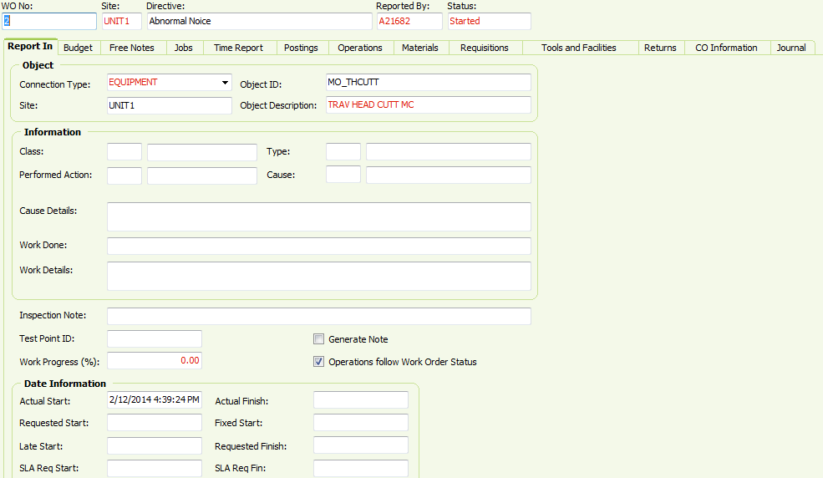
Go to the Time Report TAB and click
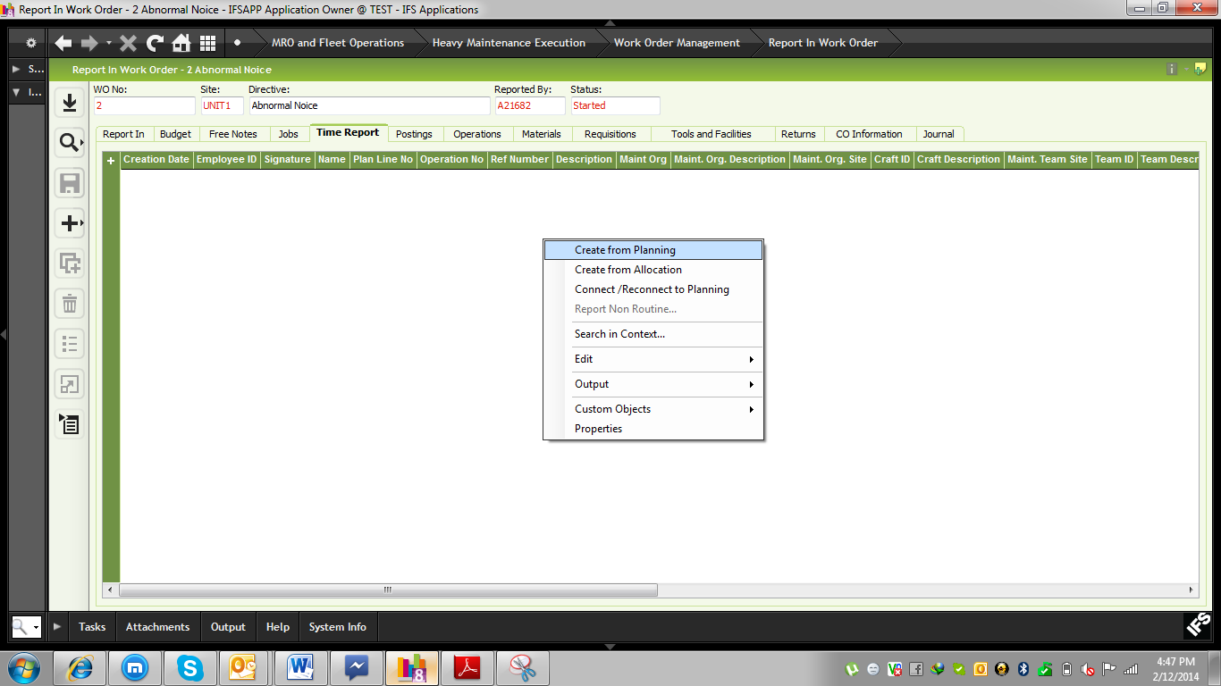

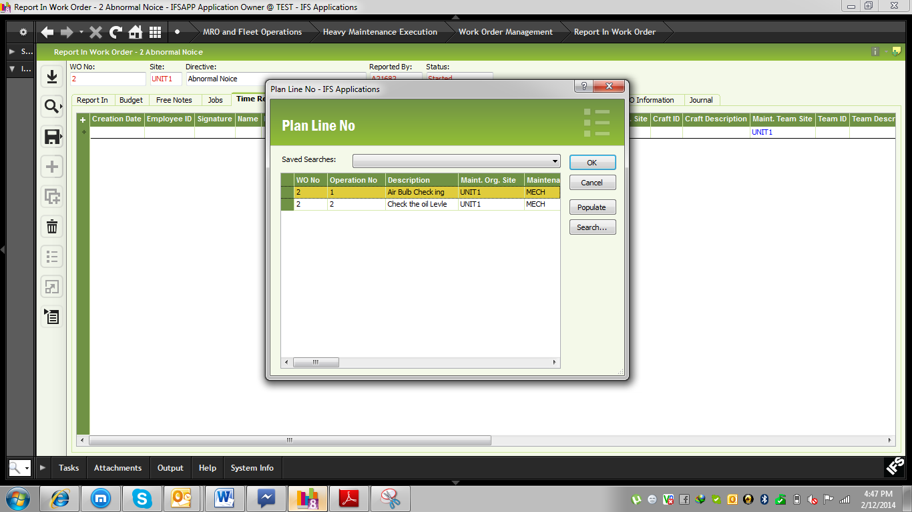
Operation wise we need to input report time
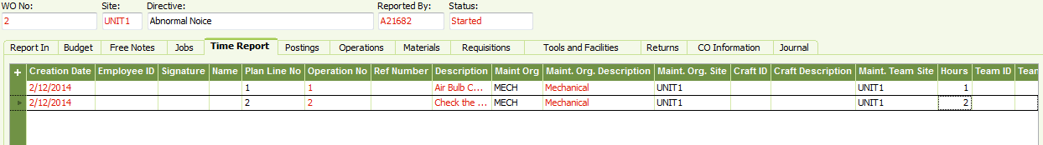
Note: In operation TAB which is defined previously 3 steps but Eng. Completed it by 2 steps then no need to report the 3rd step.
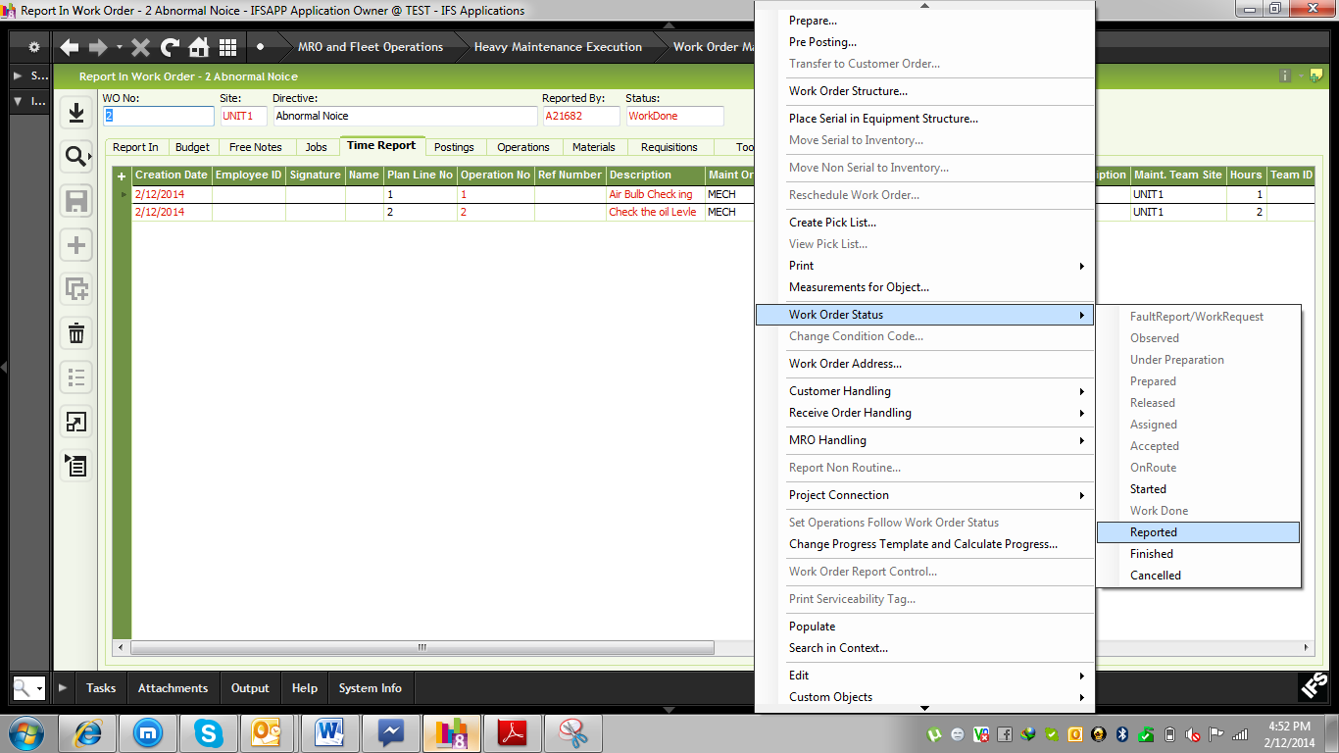

To authorized everything
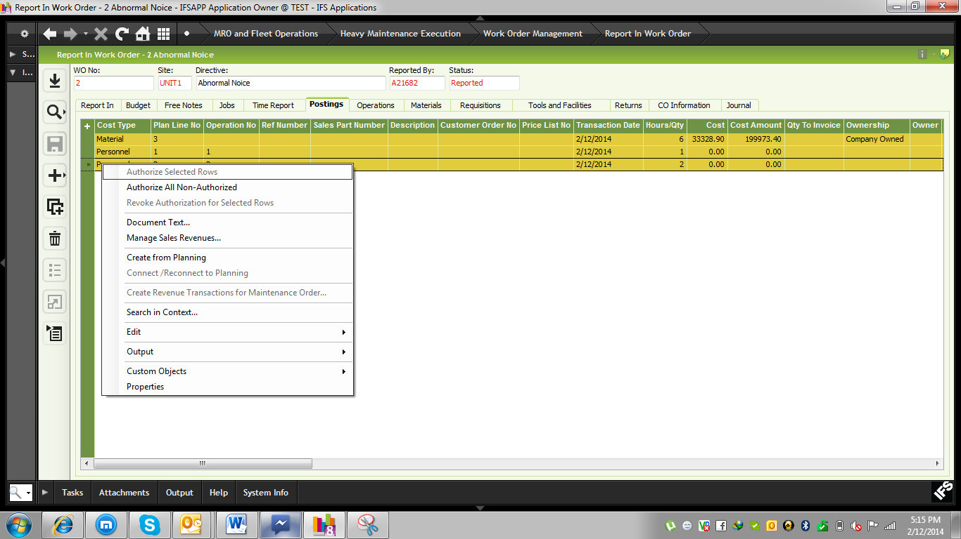
After then RMB on the header and click Work Order Status> Finished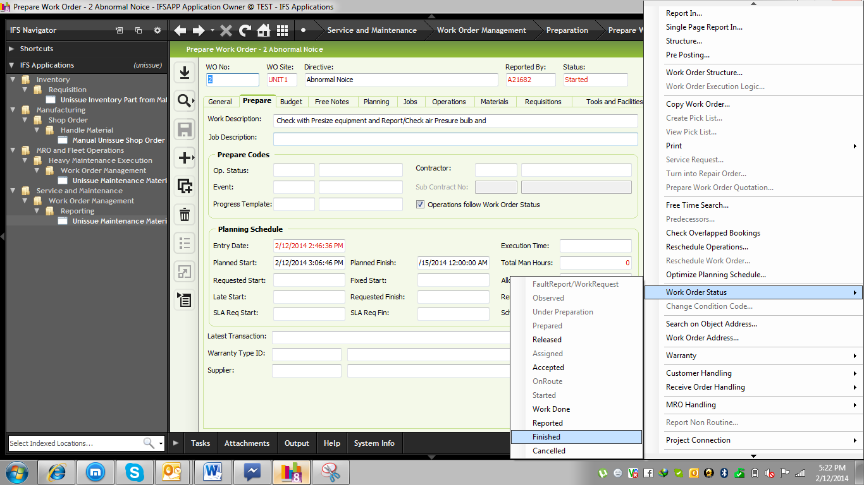

For Taking Machine Measurement then RMB on the header and click “Measurements for objects”
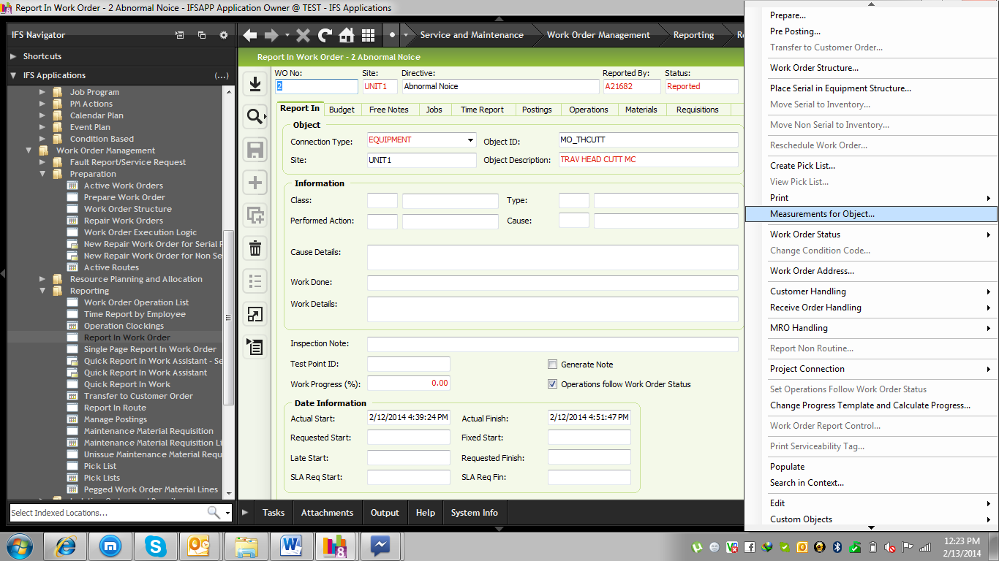
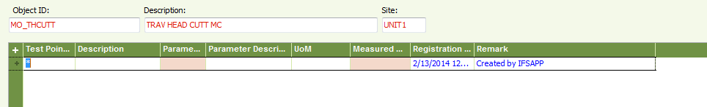

Note: IF Inventory item is not available at Store during issue that time user can create Material Requisition.
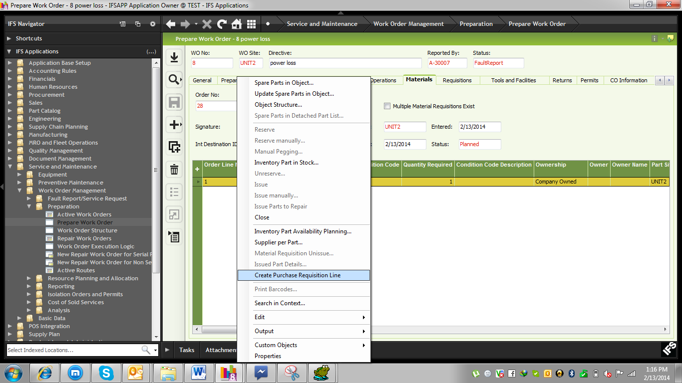
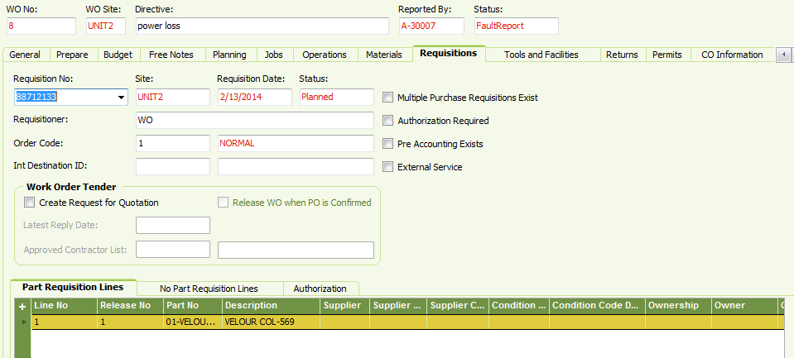

For Service we need to Create Requisition. Create new Line and input into “Description”, Supplier (Service Supplier) and “Price/Curr”
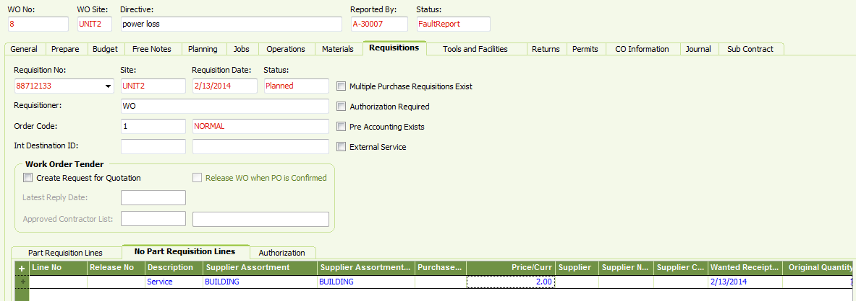

Historical Information:

Path: Service and Maintenance\Work Order Management\Analysis\Historical Work Orders

9. Preventive Maintenance
Method of Preventive maintenance is:
- Calendar Base- Fixed Frequency we will generate
- Event Base – On Special activities like New Year/ Year End
- Condition Base – Based on measurement need to perform maintenance work order.
PM action categorize based the method of performing work order.
- Separate PM Action – Object> work Order( one to one)
- Route PM Action – Many object > One work order( Many to One)

9.1 Create PM action based on “Separate PM Action”

Path: Service and Maintenance\Preventive Maintenance\PM Actions\Separate PM Action
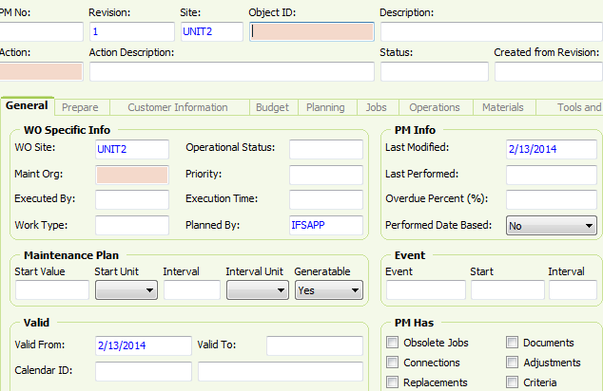
In Action filed we will define our all actions
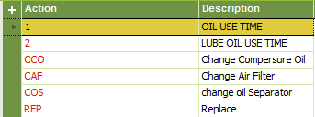

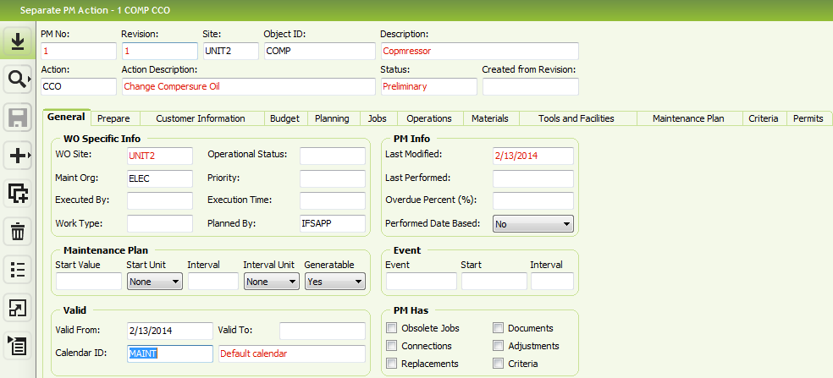
In “Maintenance Plan” block we will input Start value and interval and interval unit.
“Start unit” can be day/week/month.
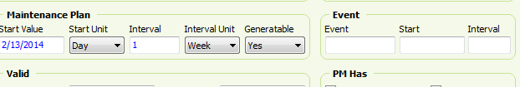
In Material TAB we will add all material which is required
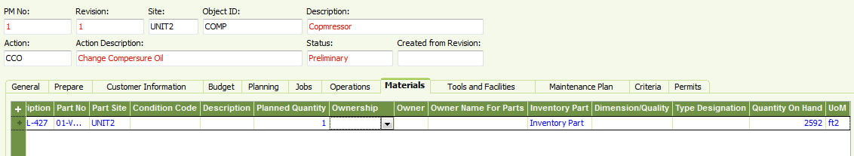
In operation tab (All Instruction) what will be action.
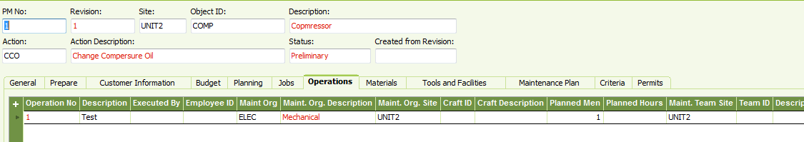
If we need extra instruction then we will add it into Prepare TAB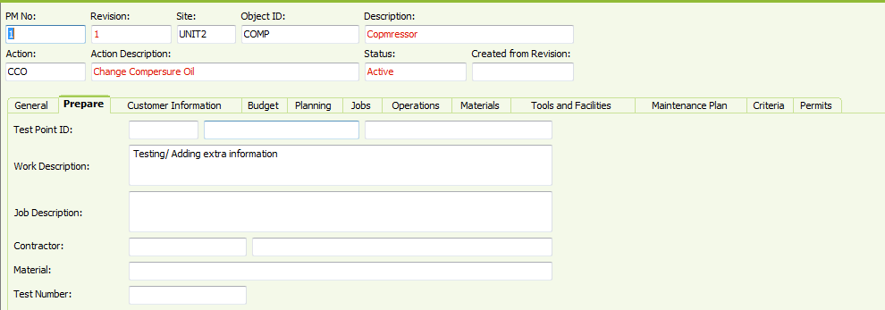
Work order will be generate based on our maintenance plan
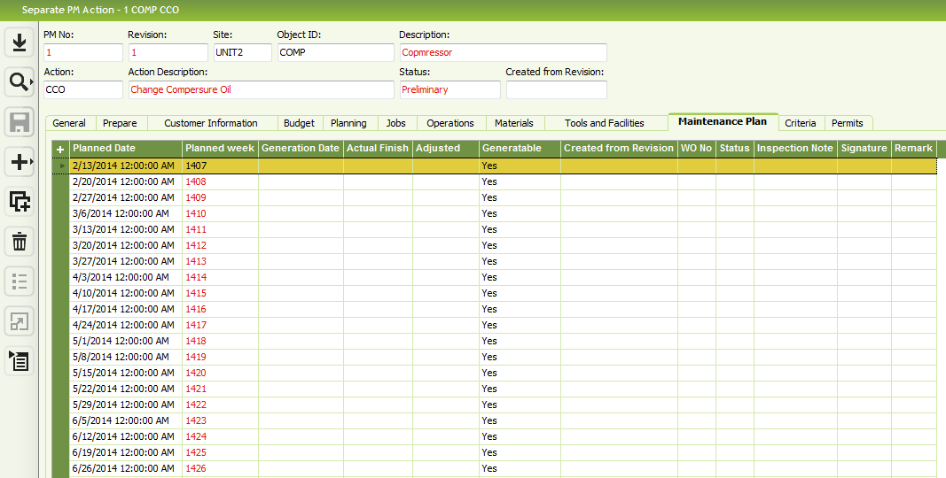
After then need to Active the action. RMB on the header and click PM Action Status>Active 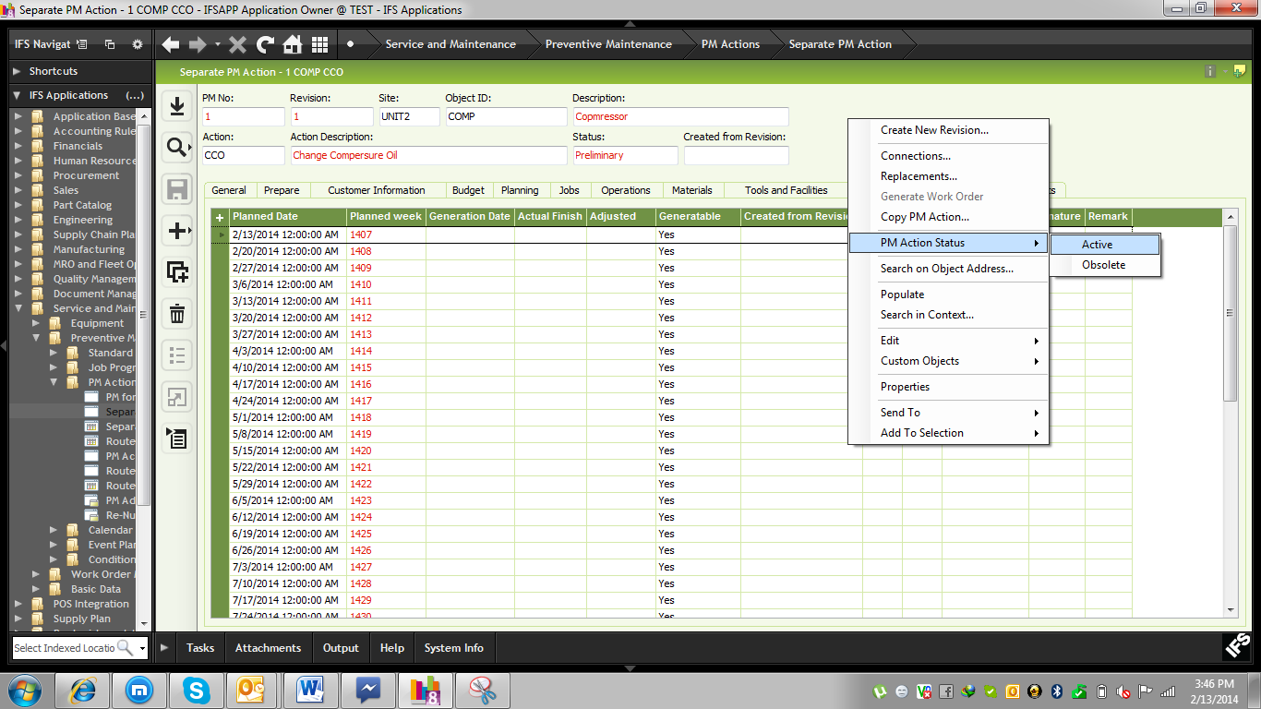
User can create Work order (Manually) for that RMB on the line and Create “Generate Work Order”
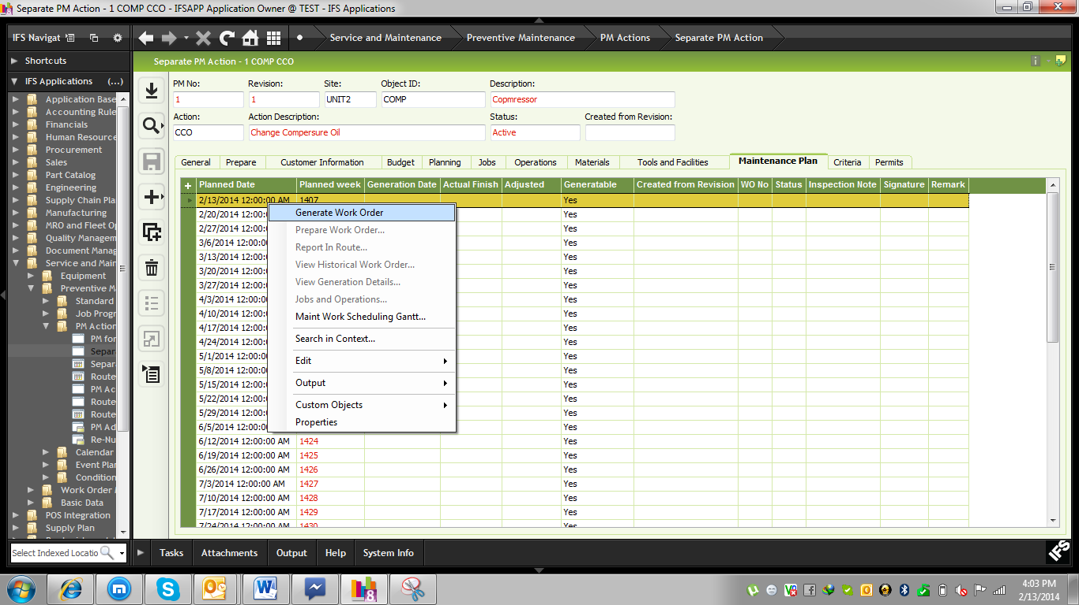
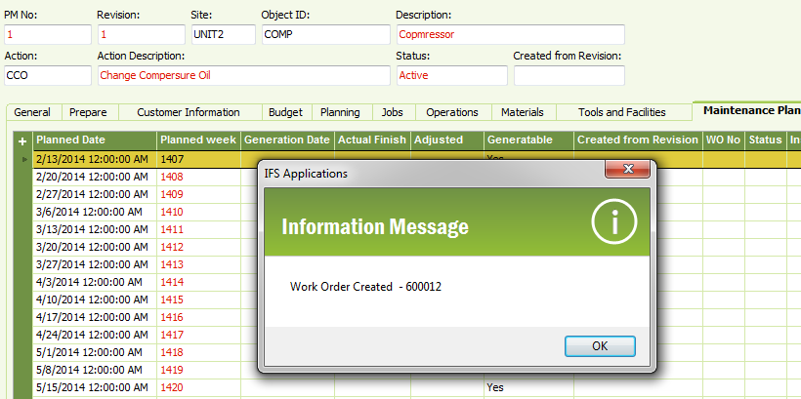

9.2 work order Generation Automatically

Path: Service and Maintenance\Preventive Maintenance\Calendar Plan\Calendar Generation
Note: In week filed we will define week which is available in “Maintenance Plan” TAB in “Planned week” field. Also we can change “date to” if we want range. If we want for specific object id then need to input in below object id and Maint Org.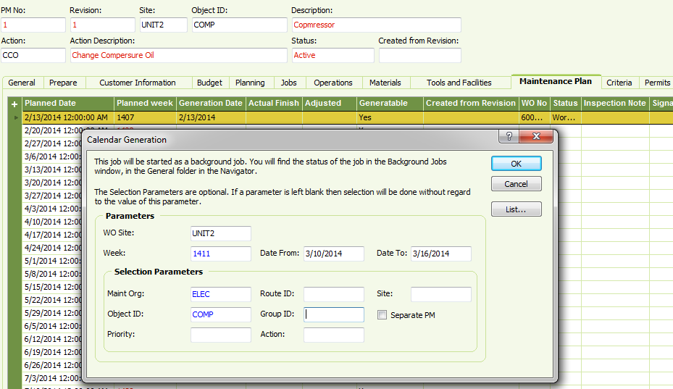
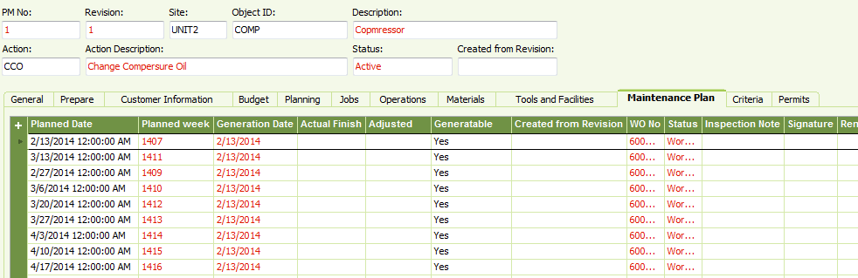
To see the work order select specific line and RMB on that line and click “Prepare”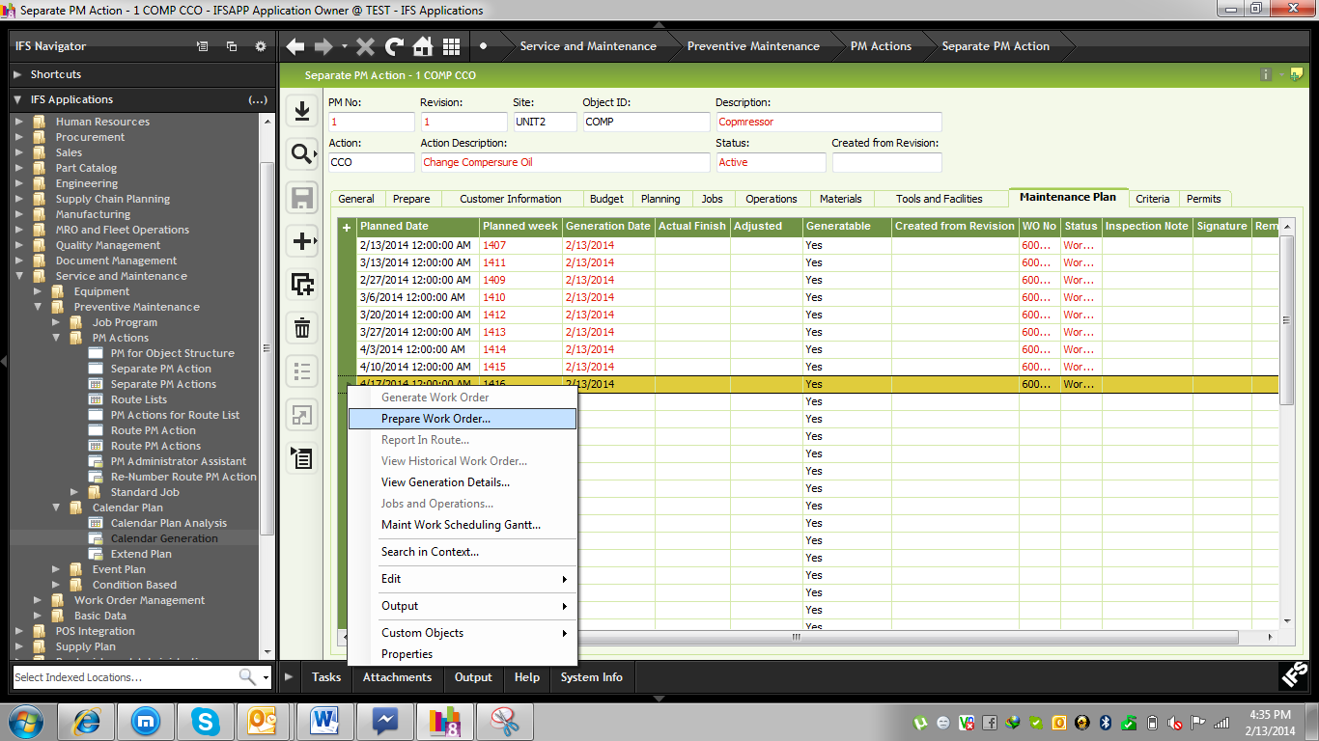
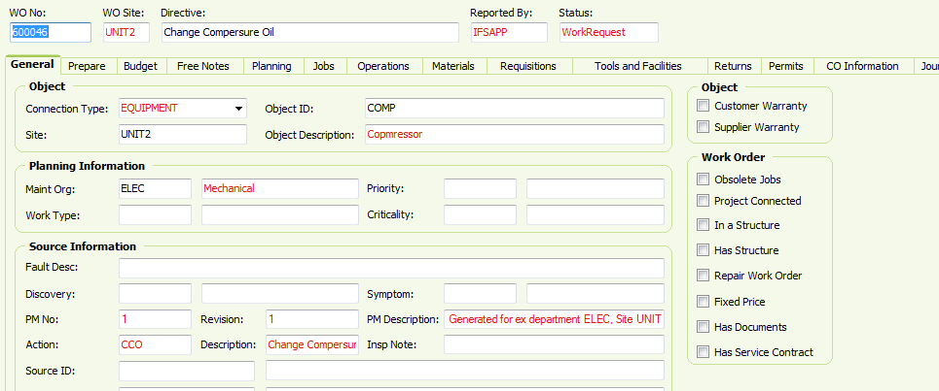

Then all process same as Corrective Maintenance which is previously defined.

9.3 Condition Base Maintenance

NOTE: For Condition base maintenance “Test Point” and “Parameter” is mandatory.
Path: Service and Maintenance\Preventive Maintenance\PM Actions\Separate PM Action
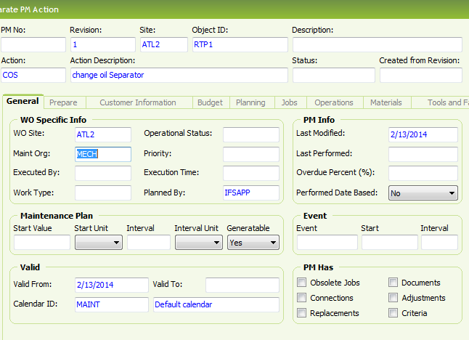
In “Criteria” TAB we will input our all condition.
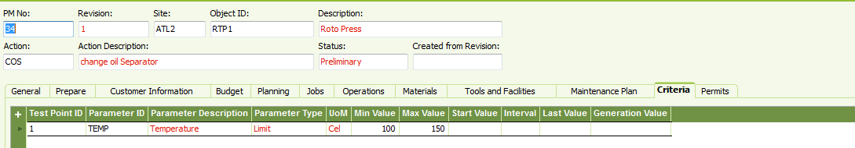
To Active the work order RMB on the header and click PM Action Status>Active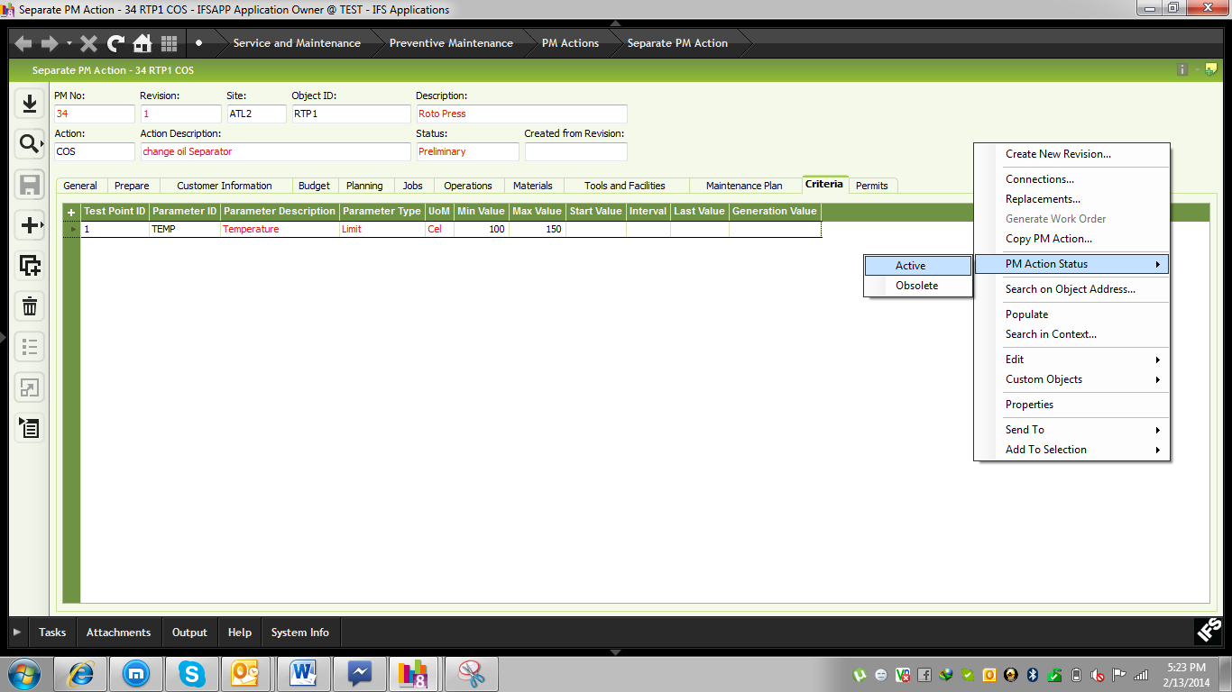
Daily maintenance user will input the measurement value. When any value is increased or decreased then trigger will be active.
Path: Service and Maintenance\Equipment\Measurements

9.4 Route PM Action
Path: Service and Maintenance\Preventive Maintenance\PM Actions\Route PM Action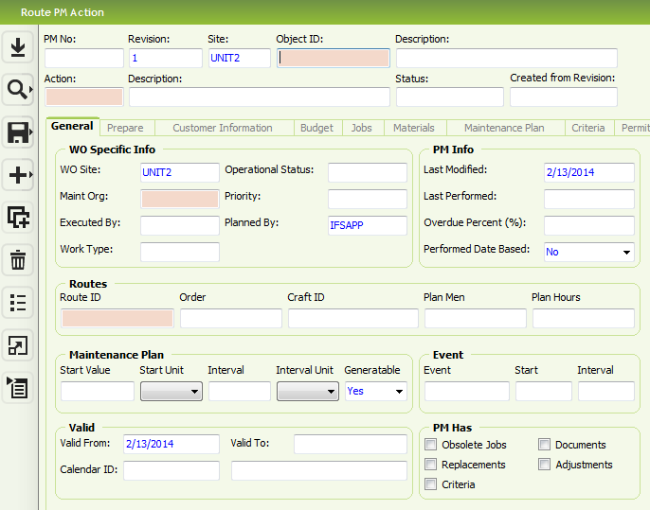
Note: Against one Route id we will add more Objects and maintenance plan will be create object wise.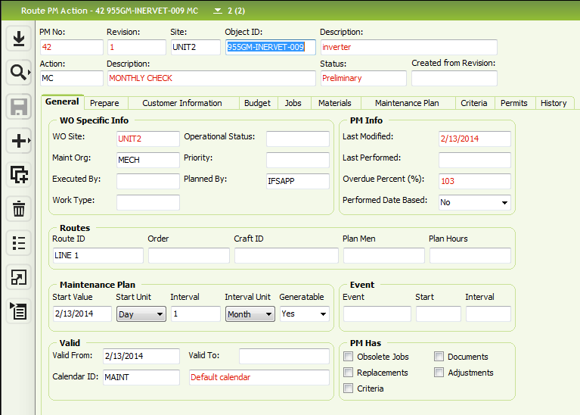
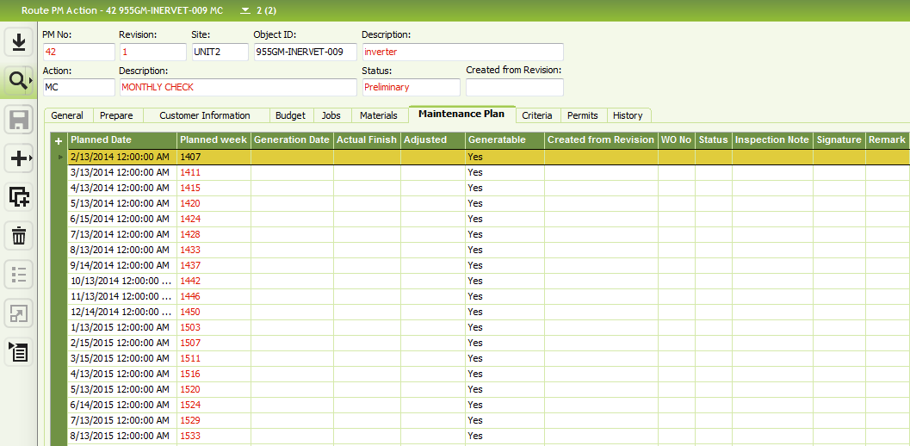
In Job TAB we will define our instruction.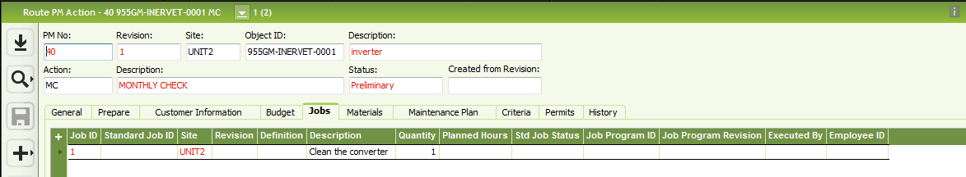
Need to active the Route Action. RMB on the header and click “PM Action Status>Active”

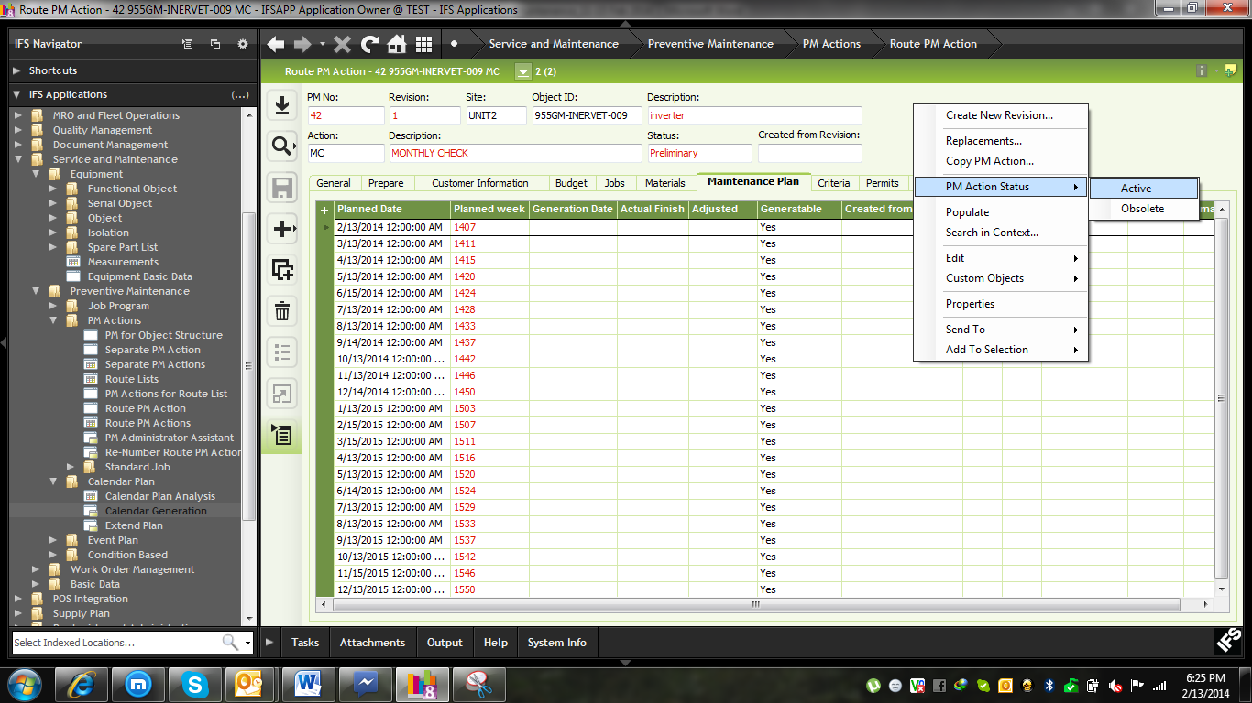

9.5 Generate work order for Route PM Action
Path: Service and Maintenance\Preventive Maintenance\Calendar Plan\Calendar Generation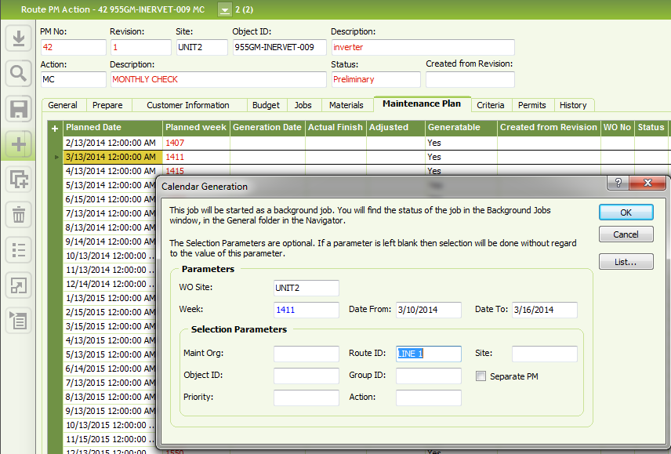
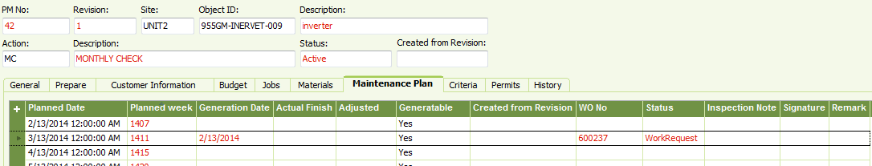
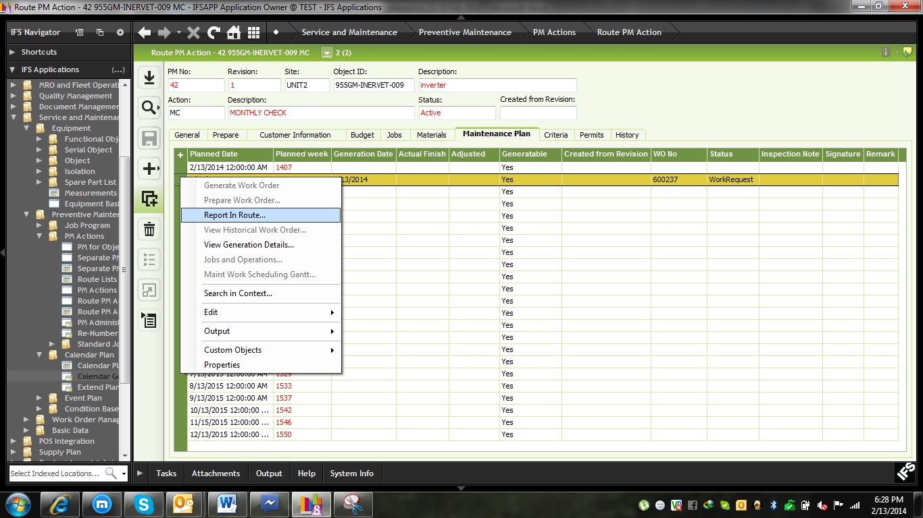
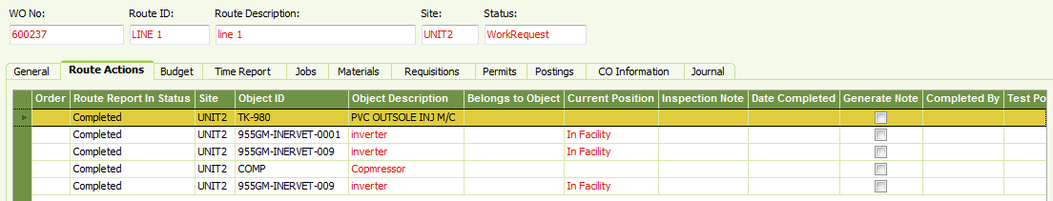

In Reporting TAB user will input the reporting information for all objects
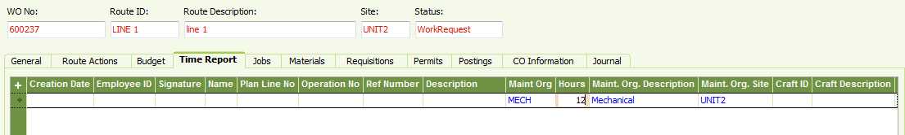
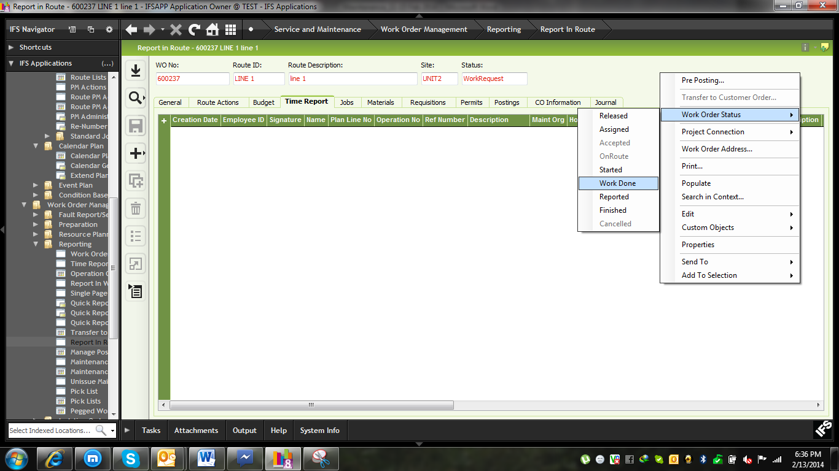

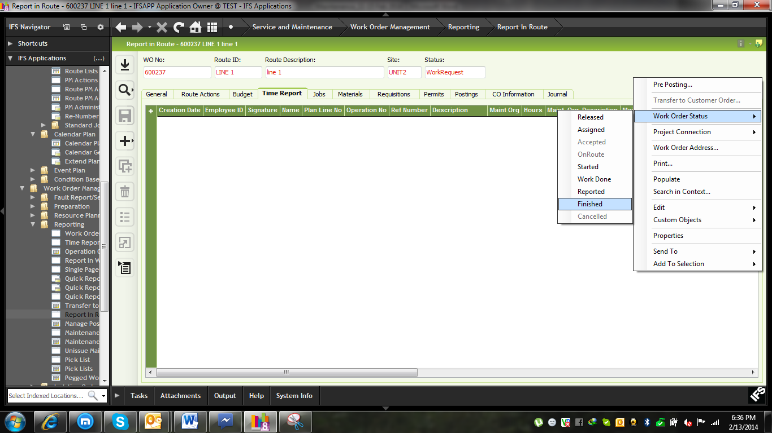

Setup Standard Jobs

Path: Service and Maintenance\Preventive Maintenance\PM Actions\Standard Job\Separate Standard Job
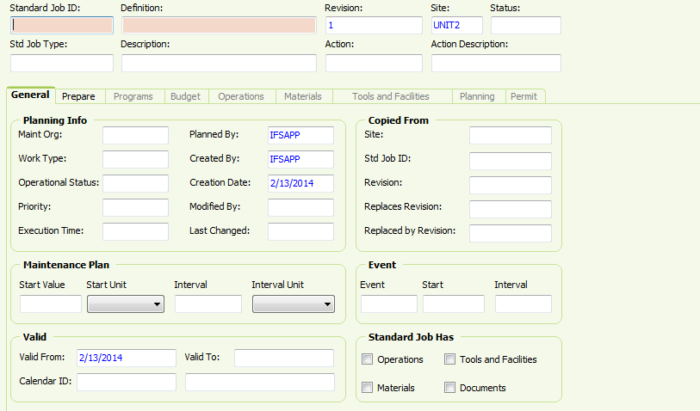

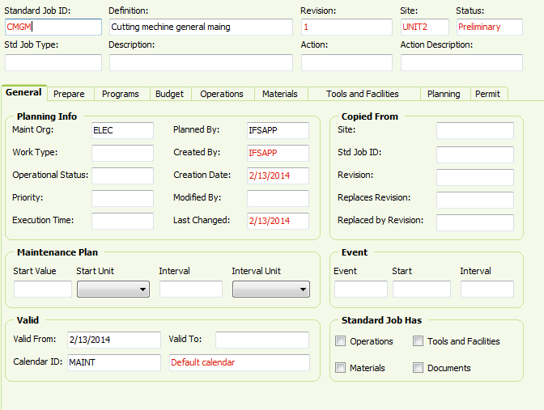
In Operation TAB all kind of Instructions
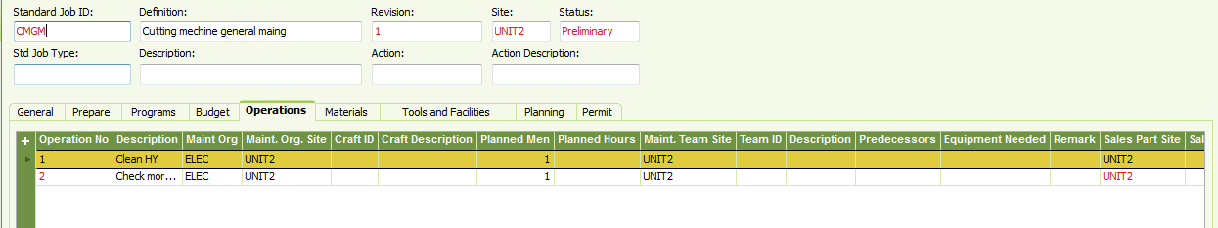
In Material TAB all materials
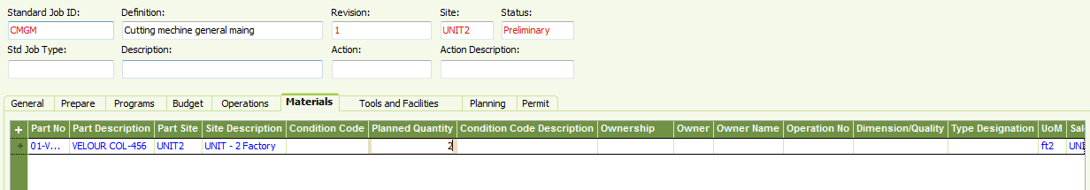

Example: Link Standard jobs
Service and Maintenance\Preventive Maintenance\PM Actions\Separate PM Action
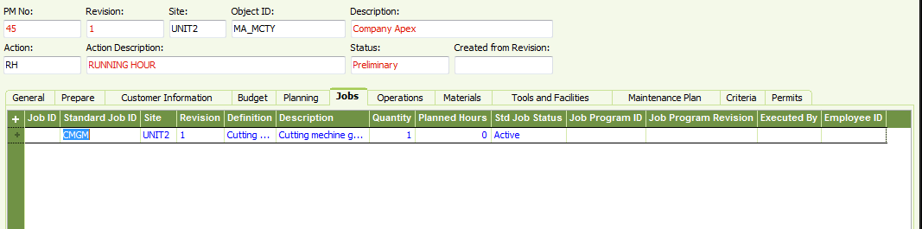

Appendix

LOV> List of Value, Set of Basic Data
RMB> Right Mouse Button

